|  |  |  |  |  |
| --- | --- | --- | --- | --- |
| **INDEX** | | | | |
| **Sr No.** |  | **Description** | | **Page No** |
| **1** |  | **DDU Profile** | |  |
| **2** |  | **Company Profile** | |  |
| **3** |  | **Project Profile** | |  |
| **4** |  | **Tools and Technologies** | |  |
| **5** |  | **Planning** | | |
|  | **5.1** | Project Definition | |  |
|  | **5.2** | Preliminary Investigation | |  |
| **6** |  | **System Analysis** | |  |
|  | **6.1** | Feasibility Study | |  |
|  | **6.2** | System Requirement Specification | |  |
| **7** |  | **System Design** | |  |
|  | **7.1** | Architectural diagrams | | |
|  |  | **7.1.1** | Use case Diagram |  |
|  |  | **7.1.2** | Activity Diagrams |  |
|  |  | **7.1.3** | Class Diagram (1. Classes/interfaces, 2. Class diagram) |  |
|  |  | **7.1.4** | Sequence Diagram |  |
|  | **7.2** | **ER Diagram** | |  |
|  | **7.3** | **Data Dictionary** | |  |
| **8** |  | **Implementation & Testing** | |  |
|  | **8.1** | Screen Snapshots | |  |
|  | **8.2** | Reports (giving important outputs of the project) | |  |
|  | **8.3** | Testing | |  |
|  |  | **8.4.1** | Test Strategy |  |
|  |  | **8.4.2** | Test Cases and Results |  |
| **9** |  | **Future Enhancement** | |  |
| **10** |  | **Bibliography** | |  |

1. **DDU Profile**

Dharmsinh Desai University (DDU), located at Nadiad is one of the leading institutions of learning in Gujarat. Since inception in 1968 as an institute for higher education in technology and engineering by the then Member of Parliament, Shri Dharmsinh Dadubhai Desai, it is committed to grooming students for leadership roles in the society.

Having modesty started with Diploma and Degree courses in Chemical Engineering. It has by now grown as top most Institute of Gujarat offering Graduate and Post Graduate level courses in various disciplines, and ultimately has become a State University in the year 2005. The institute gained an autonomous status in 1999 with approval from UGC and Gujarat Government and become a Deemed University accredited by N.B.A. in the year 2000.This University offers Graduate and Post Graduate level courses in various disciplines and Master of Computer Applications (MCA) is being run under Faculty of Management and Information Science since 1987. DDU’s Mission is to undertake programs and projects for development of human resources, both through formal and non- formal delivery systems, in areas of professional pursuits in all walks of human endeavors, with accent on relevance, value addition, societal needs and futuristic pilot projects.

In November 2013, the organization in UK, the 'Oxford Summit of Leaders', chose Dharmsinh Desai University as the best regional university. This is the first time the Oxford Group has given this award to a university outside Europe. The University has been accredited by UGC NAAC.

D.D. University believes not only in providing quality education, but also provides an overall development of its students in the form of being disciplined, sociality accountable to the society and responsible citizen of our county.

The University runs various courses in Technology, Pharmacy, Management and Information Sciences, Dental Sciences, Medical Sciences.

1. **Company Profile**



**Company Name**: Proses Web Technologies Pvt. Ltd.

Company Address: 311,312 Park Paradise, Ring Rd, near Billabong High school, Vadsar, Kalali, Vadodara, Gujarat 390012

# Company Overview:

PROSES is a place where innovative business ideas are converted into

Technical reality. Established in 2005 with a purpose to bring positive difference in the business modules with the involvement of advanced technology. Our idea is to connect the dots of the businesses with web technology to ensure flawless and quick completion of the distinct business procedures. This helps businesses to grow at rapid pace in brief time.

# Mission:

We believe not only in offering solution but ensuring positive connection with our clients. Thus, we offer endless solution to our customers and seek for further assistance needed by our customers. This makes us trusted customer-centric solution provider. Therefore, our mission varies with the requirements of the

Clients. After-all, we just not work for them but we live their projects.

# Services:

Web Development Mobile Development IOT / Beacons UI/UX

Sound Support

At PROSES, we work at the core concept of web and mobile development

Where we look at every single aspect and requirement of the clients; so that both can be inter weaved into an application to ensure high-end web & mobile

1. **Project Profile**

|  |  |
| --- | --- |
| **Company name** | Proses Web Technologies Pvt. Ltd |
| **Project title** | Employee Management System |
| **Project Definition** | An employee management system or EMS is a tool that helps improve employee satisfaction and productivity to help a company achieve their overall goals. |
| **Project description** | The Employee Management System (EMS) is a software application designed to Management of employee data within an organization. This system provides functionalities for managing employee information, such as personal details,  leave requests  **admin:** Admin (Full Rights)  **manager:** employee(Rights) |
| **Aim of Project** | Employee Management System Project is designed to keep track of employee information in any company. It stores data such as their employees' personal information leave details |
| **Tools/Technologies** | HTML, JavaScript, React, Bootstrap, MySQL, Node |
| **Duration** | 4 Month |
| **Team Size** | 1 |
| **Type** | Web Application |
| **Internal guide** | **Prof. Minal Shah** |
| **External guide** | **Mr. Parthiv Shah** |

1. **Tools and Technologies**

|  |  |
| --- | --- |
| **Front End** | HTML, Bootstrap, JavaScript, React js |
| **Back End** | Node js |
| **Database** | MySQL Server |
| **Tools/ Technology** | Visual Studio Code, |
| **Type of application** | Web Application |

1. **Planning**
   1. **Project Definition**

An employee management system is a system that helps to improve employee management and productivity to help a company achieve their overall goals. These system help monitor, assess and control employees' working hours. It include Manager efficiently manages each employee's information and distribute salaries.

With the help of employee management system the Manager department can implement processes and help companies achieve their business objectives. By helping managers keep track of admin activities, the system can help improve employee engagement and increase productivity. These system also help an organization for Leave management.

* 1. **Preliminary Investigation**

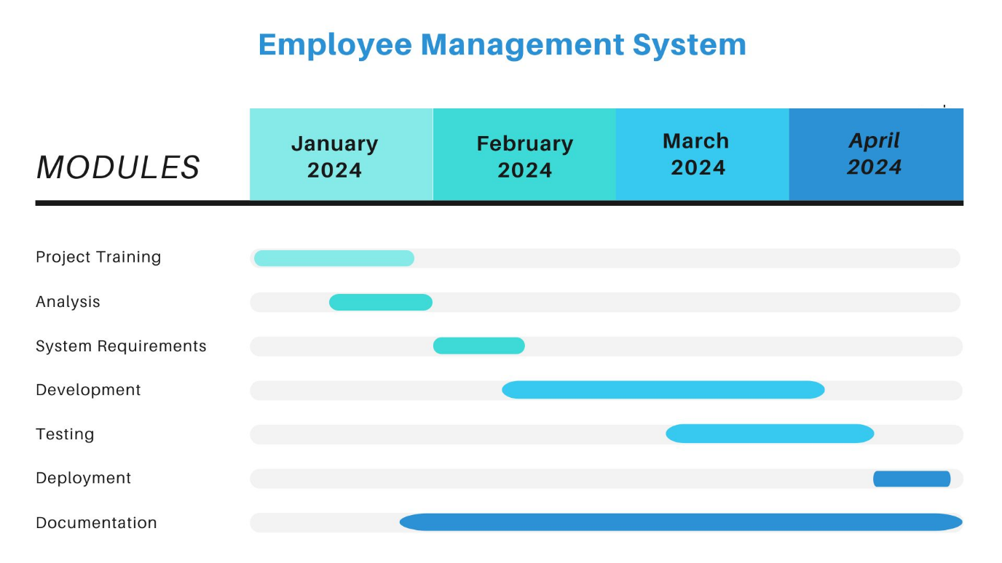

1. **System Analysis**
   1. **Feasibility Study**

* **Technical Feasibility:**
* **System Requirements**:

The EMS will require technical infrastructure including servers, databases, and network connectivity. Assessing the availability of these resources within the organization or the ability to procure them externally is essential.

* **Technology Stack:**

Determine the feasibility of using appropriate technologies for development, considering factors such as compatibility, scalability, and integration capabilities with existing systems.

* **Security**:

Evaluate the feasibility of implementing robust security measures to safeguard employee data, including encryption, access controls, and regular security audits.

* **Economic Feasibility:**
* **Cost Analysis**:

Estimate the development, deployment, and maintenance costs associated with implementing the EMS. Consider factors such as software licensing, hardware infrastructure, development resources, and ongoing support.

* **Return on Investment (ROI**):

Assess the potential ROI by quantifying the benefits of the EMS, such as improved employee productivity, streamlined HR processes, reduced administrative overhead, and compliance with labour laws. Compare these benefits against the projected costs to determine economic feasibility.

* **Operational Feasibility:**
* **User Requirements:**

Gather user requirements from HR professionals, managers, employees, finance department, training teams, and recruiters to ensure that the EMS meets their operational needs.

* **Change Management:**

Assess the organization's readiness for adopting the EMS, including potential resistance to change and strategies for managing organizational change effectively. Consider factors such as user training, communication plans, and stakeholder engagement.

* **Legal and Regulatory Feasibility:**
* **Data Privacy and Compliance:**

Ensure that the EMS complies with data protection regulations (e.g., GDPR, HIPAA) and labour laws regarding employee records, working hours, payroll processing, and confidentiality. Assess the feasibility of implementing necessary controls and procedures to achieve compliance.

* **Schedule Feasibility:**
* **Project Timeline**:

Develop a detailed project plan with milestones and deadlines for different phases of development, testing, deployment, user training, and support. Assess the feasibility of meeting these timelines based on resource availability, complexity of the project, and potential risks.

**Index**

|  |  |  |  |  |
| --- | --- | --- | --- | --- |
| **Sr No.** |  |  | **Topic** | **Page No** |
| **1** |  |  | **Introduction** |  |
|  | **1.1** |  | Purpose |  |
|  | **1.2** |  | Definition |  |
|  | **1.3** |  | Scope |  |
|  | **1.4** |  | Intended Audience and Users |  |
| **2** |  |  | **Overview** |  |
|  | **2.1** |  | Environmental Characteristics |  |
|  |  | **2.1.1** | Hardware / Software |  |
|  |  | **2.1.2** | Peripheral |  |
|  |  | **2.1.3** | People |  |
|  | **2.2** |  | Overview |  |
|  | **2.3** |  | Acronyms & Abbreviation |  |
|  | **2.4** |  | References |  |
| **3** |  |  | **Specification Requirements/ Functional Requirements** |  |
|  | **3.1** |  | User Authentication |  |
|  | **3.2** |  | User Interface |  |
|  | **3.3** |  | Various roles |  |
|  | **3.4** |  | User Class |  |
|  |  | **3.4.1** | Attributes |  |
|  |  | **3.4.2** | Methods |  |
|  |  | **3.4.3** | Access Control |  |
|  |  | **3.4.4** | Password Management |  |
|  |  | **3.4.5** | Relationships |  |
| **4** |  |  | **Non-Functional Requirements** |  |
|  | **4.1** |  | Accessibility, Reliability and Availability, Performance, Security |  |
|  | **4.2** |  | Interfaces |  |
|  |  | **4.2.1** | User Interfaces |  |
|  |  | **4.2.2** | Software Interfaces |  |
|  |  | **4.2.3** | Communication Interfaces |  |
| **5** |  |  | **Behavioral Description** | |
|  | **5.1** |  | System States |  |
|  | **5.2** |  | Events and Actions |  |

* 1. **System Requirement Specification**

1. **Introduction**

The Employee Management System (EMS) is a software application designed to streamline the management of employee data within an organization. This system provides functionalities for managing employee information, such as personal details, attendance, leave requests, performance evaluations, and payroll processing.

* 1. **Purpose**

The purpose of this document is to define the requirements for the development of an Employee management to manage Human resource effectively as well as efficiently by the employer. The system is created for the core purpose is to manage employee things and togetherness of three core tires of every organization. And being helpful to an organization.

* 1. **Definition**

The Employee management system describes the management of employee and all the authorization are in the hands of admin and some of part through the manager.

* 1. **Scope**

The Employee management system is used by human resource managers as well for analysers of any organization. It includes salary of every employee, admin can add, update, delete employee, admin can also modify data within the system as well as leave of employees are goes under the managers.

* 1. **Intended Audience and Users**
* **Human Resources (HR) Professionals:**

These are the main users of Employee management system. They have to work on their human resource and make them feel better as well as via less efforts. All this requirements can filled up by the Employee management system.

* **Decision-makers:**

Decision-makers, including executives and organizational leaders they have to analyse on organizations man power as well as they can take decision regarding new joining as well as their management.

* **Data Analysts:**

Another important audience is data analyst. Their main work is to analyse employee data while distributing allowances, their expenses on their human property.

1. **Overview** 
   1. **Environmental Characteristics** 
      1. **Hardware/Software**

**Software**

Name of component Specification

Operating System Windows7, Windows10, Windows11

Language React, HTML, JavaScript, Bootstrap,

CSS.

Database MySQL Server

Browser Chrome, Internet Explorer, Microsoft Edge

Web Server Apache

Software Development Kit Node

Scripting Language Enable JavaScript

## **Hardware**

Name of component Specification

Processor Intel(R) Core (TM) i5-5200U

Monitor 15” Color Monitor

RAM 8 GB

Hard disk 20GB

Keyboard 122 Key

* + 1. **Peripheral**

No specific peripheral hardware is required for accessing the Dashboard of Employee management system. Employee, manager and admin can interact with the platform using standard input devices such as keyboards and mice, along with displays (monitors/screens) for visualizing the data.

* + 1. **People**
* **Development Team:**

**Software Engineers:** Responsible for developing frontend and backend components, implementing features, and ensuring system functionality.

**UI/UX Designers:** Design user interfaces, wireframes, and prototypes for optimal user experience.

* **End-users:**

**Employee:** This are the vital role who use this system. To show their profile, attendance, salary.

**Admin:** The handler or in other words primary user which handles the data, authorizations, protocols etc.

**Managers:** The middleware or which are being monitors of the Employee Management System.

**Human Resources Managers:** Use demographic and income data to understand workforce characteristics and plan recruitment strategies.

* 1. **Overview**

The Employee Management System is used to handle employee data and being easy handler to manage human force and their profiles.

* 1. **Acronyms & Abbreviation**

Employee Dashboard (ED): The web-based platform designed to showcase Employee data.

EMS: Employee Management System

HRMS: Human Resource Management System

HRIS: Human Resources Information System

EHR: Employee Health Record

EIS: Employee Information System

TMS: Talent Management System

ATS: Applicant Tracking System

PMS: Performance Management System

T&A: Time and Attendance

DMS: Document Management System

* 1. **References**

Human resource activities

Node libraries

1. **Specification Requirements/ Functional Requirements**

* A log in facility for enabling only authorized access to the system.
* System administrator will be able to add, modify, enable, disable or delete any feature like, employee information, and login information.
* System administrator will be able to create login credentials for new employees.
* Employees will be able to view their information.
* An employee cannot view other employee details.
  1. **User Authentication**

**Requirement 3.1.1:** Users must authenticate themselves before accessing the Employee management dashboard.

**Requirement 3.1.2:** Authentication mechanisms such as Email and password.

* 1. **User Interface**

**Requirement 3.2.1:** The dashboard shall display various navigates to Display employee data.

**Requirement 3.2.2:** Admin can add and update employee and employee can get data.

* 1. **Various roles**

**Requirement 3.3.1:** There is 3 roles and all of them can get their Screens. There are Employee, manager, admin.

* 1. **User Class**
     1. **Attributes**

Employee ID: A unique identifier for each employee.

Name: The full name of the employee.

Username and Password: For user authentication and access control.

Contact Information: Such as email.

Position: The position or role of the employee within the organization. Department: The department to which the employee belongs.

* + 1. **Methods**

Getters and Setters: For accessing and updating the attributes of the user. Authentication: Verify the username and password for login purposes.

Update Profile: Allow the user to update their contact information. View Personal Information: Display the employee's details.

* + 1. **Access Control**

Authorization Check: Ensure that the user has the necessary permissions for certain actions or access.

* + 1. **Password Management**

Password: passwords, ensure they are secure.

* + 1. **Relationships**

Manage Relationships: If the system involves hierarchical relationships or reporting structures, the User class may need methods to manage these relationships

1. **Non-Functional Requirements**

* Employees never allowed to modify their or other employee’s information. Such attempt will be reported to the administrator.
* Employees can change their password when they wan
  1. **Accessibility, Reliability and Availability, Performance, Security**
* **Accessibility:**

The Employee Dashboard shall comply with accessibility standards, ensuring that it is accessible to users with disabilities. This includes:

* Providing alternative text for images and visual elements for screen readers.
* Ensuring keyboard navigation functionality for users who cannot use a mouse.
* Maintaining adequate colour contrast and font sizes for readability.
* **Reliability and Availability:**

The Employee dashboard shall have a reliable uptime of at least 99%, ensuring that it is consistently available for employees.

* Regular maintenance and updates to address any potential issues promptly.
* Monitoring system performance and availability to proactively identify and resolve any issues.
* **Performance:**

The Employee dashboard shall load within 3 seconds on standard internet connections to ensure optimal user experience. This includes:

* Optimizing front-end and back-end code to reduce loading times.
* Implementing caching mechanisms to speed up data retrieval and rendering processes
* **Security:**

The Employee dashboard shall ensure the security of data transfer and storage to protect sensitive information.

* Implementing encryption protocols such as HTTPS for secure data transmission over the network.
* Utilizing secure authentication mechanisms to restrict access to authorized users only.
* Regular security audits and updates to address any vulnerabilities and ensure compliance with industry standards.
  1. **Interfaces**
     1. **User Interfaces**

The Employee dashboard shall have an effective and user-friendly interface that allows users (Employee, manager, admin) to interact with data and display features efficiently.

* + 1. **Software Interfaces**

The Employee dashboard shall integrate with various software components and services to support its functionality. This includes:

Integration with frontend frameworks such as React for building user interfaces.

Integration with backend frameworks such as Node for handling server-side logic and APIs.

Integration with database systems such as MySQL and Mongo DB for data storage and retrieval.

* + 1. **Communication Interfaces**

The Employee dashboard shall support communication interfaces for exchanging data and information between different components. This includes:

APIs and web services for communicating with external files and data sources. Such as database

1. **Behavioral Description**
   1. **System States**

* **Admin Login State:**

Transitioned to when an admin logs into the system. The system authenticates the user credentials.

* **Employee Login State:**

Transitioned to when an Employee logs into the system. The system authenticates the user credentials.

* **Manager Login State:**

Transitioned to when a Manager logs into the system. The system authenticates the user credentials.

* **Employee Information Viewing State:**

Entered when a user accesses the employee information module. The system displays employee details.

* **Manager Information Viewing State:**

Entered when a user accesses the Manager Information module. The system displays relevant Manager Details.

* **Admin Information Viewing State:**

Entered when a user accesses the Admin Information module. The system displays relevant admin details.

* **Manager Information Editing State:**

Entered when a manager is authorized to edit Manager Information and Employee Information. The system allows modifications to Manager and Employee records.

* **Admin Information Editing State:**

Entered when an admin is authorized to edit admin information, Manager Information, Employee Information. The system allows modifications to admin, employee and manager records.

* **New Employee State:**

Entered when a user initiates the on-boarding process for a new employee. The system prompts the Manager and admin to enter relevant information for the new employee.

* **Leave Request State:**

Transitioned to when an Employee logs into the system. The system authenticates the employee credentials. And employee can apply leave and manager have rights to approve and decline leave Request.

* 1. **Events and Actions**
* **Admin Login Event:**

Action: The system verifies Admin credentials and transitions to the Login State if successful.

* **Manager Login Event:**

Action: The system verifies manager credentials and transitions to the Login State if successful.

* **Employee Login Event:**

Action: The system verifies employee credentials and transitions to the Login State if successful.

* **View Employee Information Event:**

Action: The system retrieves and displays the relevant employee information.

* **View Admin List Event:**

Action: The system retrieves and displays the relevant admin list.

* **View manager Information Event:**

Action: The system retrieves and displays the relevant manager information.

* **Edit Employee Information Event:**

Action: The system allows the user to modify employee records after proper authorization.

* **Edit Admin Information Event:**

Action: The system allows the user to modify admin records after proper authorization.

* **Edit Manager Information Event:**

Action: The system allows the user to modify manager records after proper authorization.

* **Admin Logout Event:**

Action: The system returns to the Idle State.

* **Manager Logout Event:**

Action: The system returns to the Idle State.

* **Employee Logout Event:**

Action: The system returns to the Idle State.

1. **System Design** 
   1. **Architectural diagram**

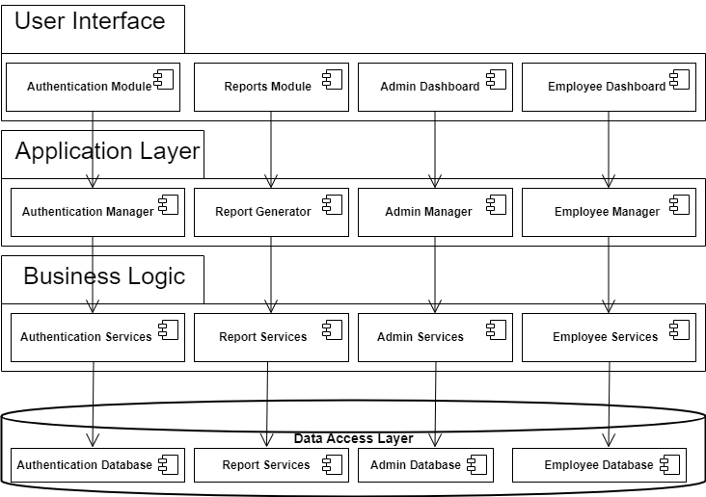

* + 1. **Use case Diagram**

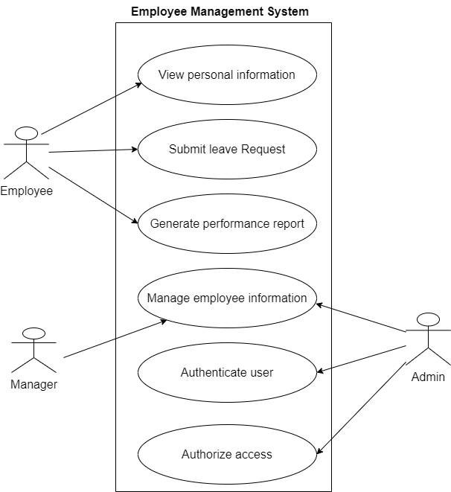

* + 1. **Activity Diagram**

**Employee Activity**

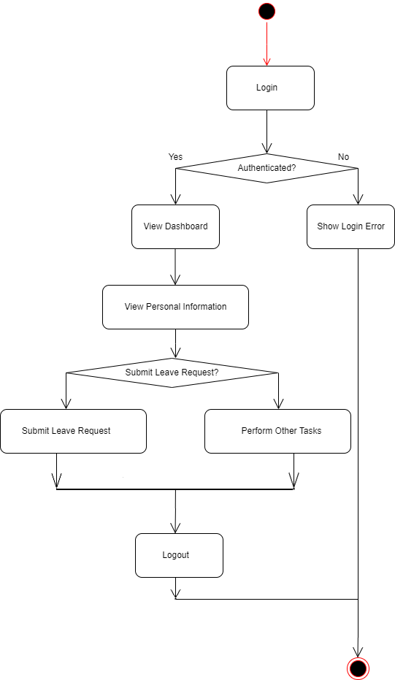

**Manager Activity**

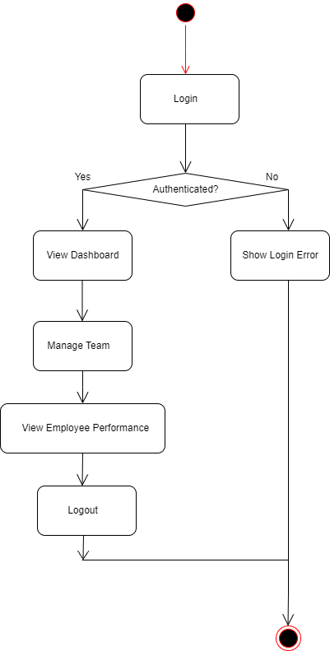

**Admin Activity**

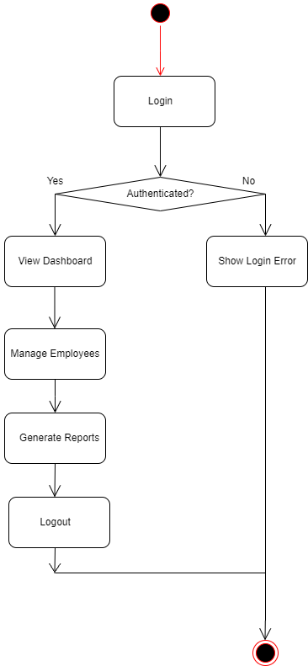

* + 1. **Class Diagram**

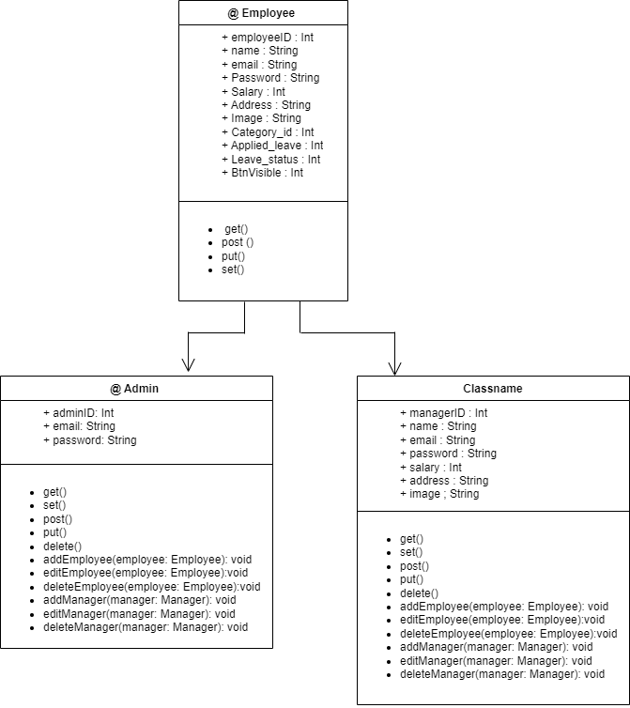

* + 1. **Sequence Diagram**

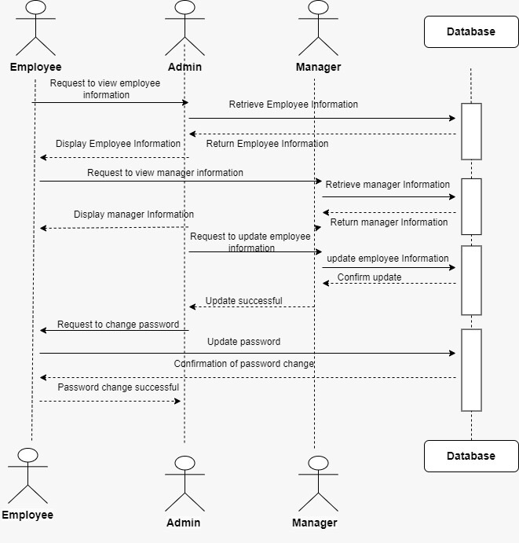

* 1. **ER Diagram**

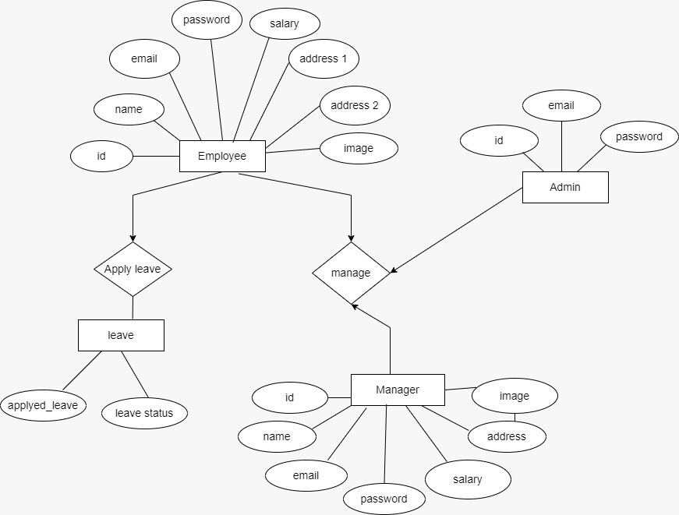

* 1. **Data Dictionary**

**Employee Table**

|  |  |  |
| --- | --- | --- |
| **Field** | **Data Type** | **Description** |
| EmployeeID | INT | Unique identifier for each employee |
| Name | VARCHAR(50) | First name of the employee |
| Email ID | VARCHAR(50) | Email Id of the employee |
| Password | VARCHAR(150) | Password of the employee login |
| Salary | INT | Salary of the employee |
| Address | VARCHAR(50) | Address of the employee |
| Image | VARCHAR(60) | Image of the employee |
| Category_id | INT | Unique identifier for each category |
| Applied_leave | INT | Applied for leave of employee |
| Leave_status | TINYINT | Check status of leave of employee |
| BtnVisible | INT | Leave Status Check at employee side |

**Manager Table**

|  |  |  |
| --- | --- | --- |
| **Field** | **Data Type** | **Description** |
| Manager Id | INT | Unique identifier for each manager |
| Name | VARCHAR(30) | Name of manger |
| Email Id | VARCHAR(50) | Email id of the manager |
| Password | VARCHAR(150) | Password of the manager login |
| Salary | INT | Salary of the manager |
| Address | VARCHAR(50) | Address of the manager |
| Image | VARCHAR(60) | Image of the manager |

**Admin Table**

|  |  |  |
| --- | --- | --- |
| **Field** | **Data Type** | **Description** |
| AdminId | INT | Unique identifier for each admin |
| Email Id | VARCHAR(50) | Email id of the admin |
| Password | VARCHAR(150) | Password of the admin login |

**Category table**

|  |  |  |
| --- | --- | --- |
| **Field** | **Data Type** | **Description** |
| Category Id | INT | Unique identifier for each Category |
| Name | VARCHAR(30) | Name of Category |

**Leave Request Table**

|  |  |  |
| --- | --- | --- |
| **Field** | **Data Type** | **Description** |
| LeaveRequestId | INT | Unique identifier for each leave request |
| Employee Name | VARCHAR(30) | Leave applied Employee name |
| Reason | VARCHAR(20) | Reason of leave (e.g., vacation, sick leave) |
| StartDate | DATE | Start date of the leave request |
| EndDate | DATE | End date of the leave request |
| Status | VARCHAR(20) | Approval status (e.g., approved, decline ) |

1. **Implementation & Testing**
   1. **Screen Snapshots**

**Employee Module**

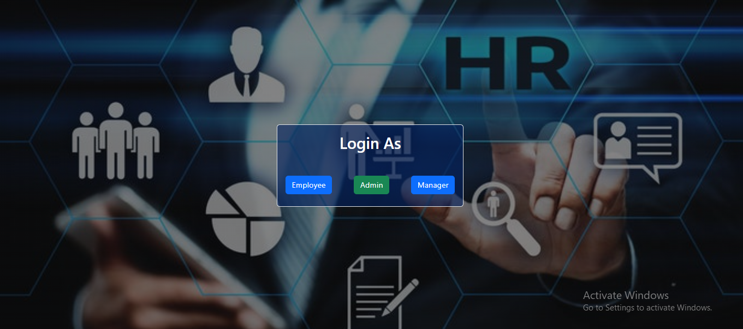

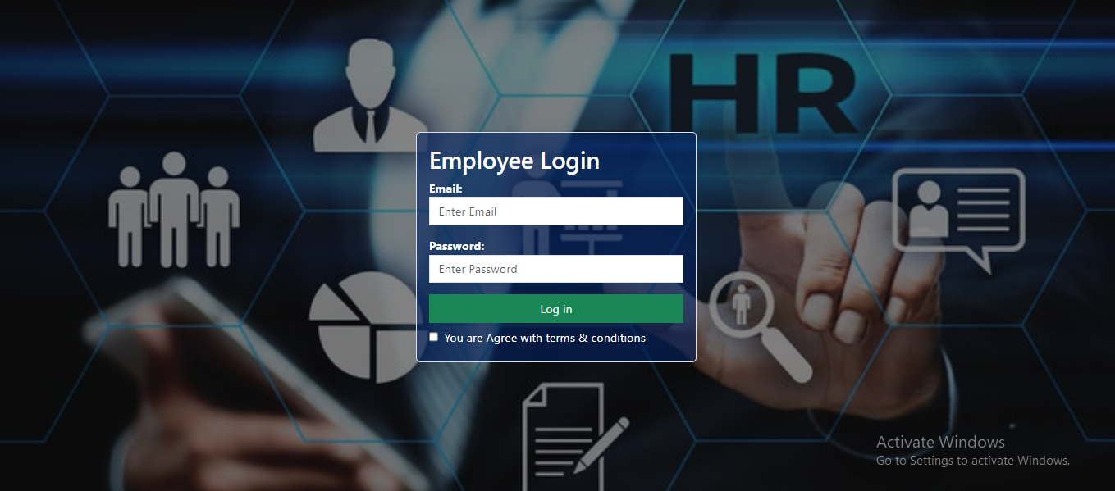

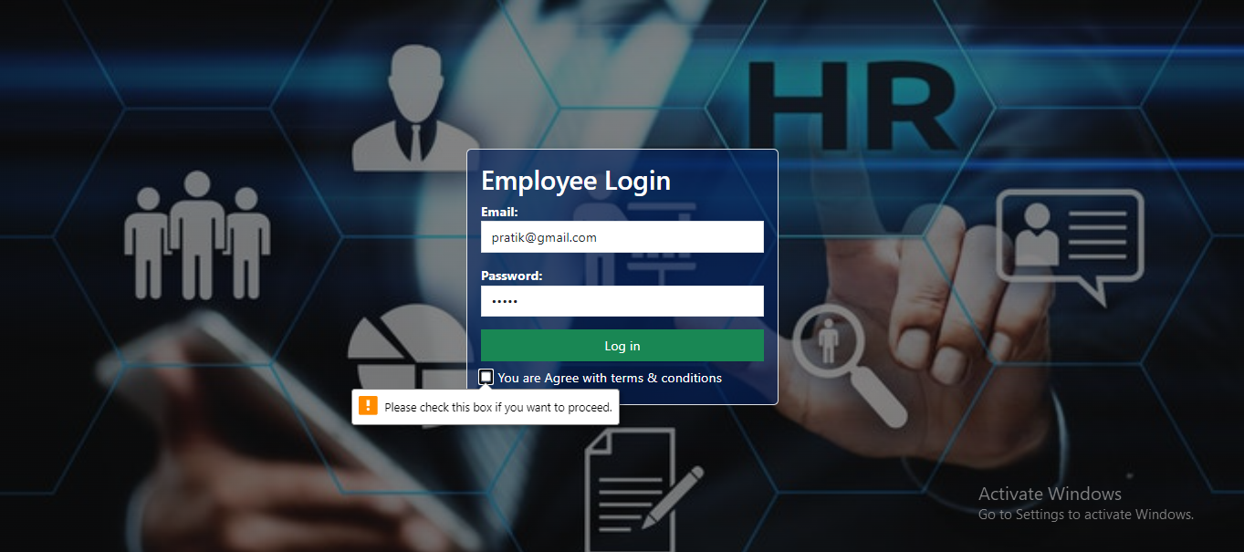

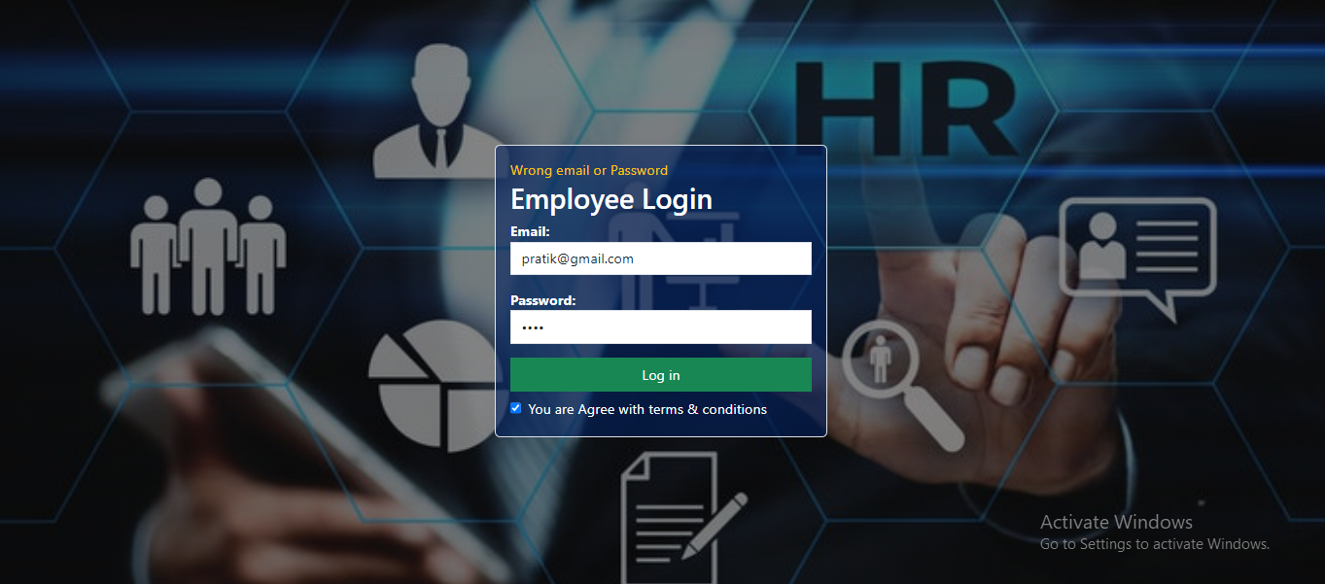

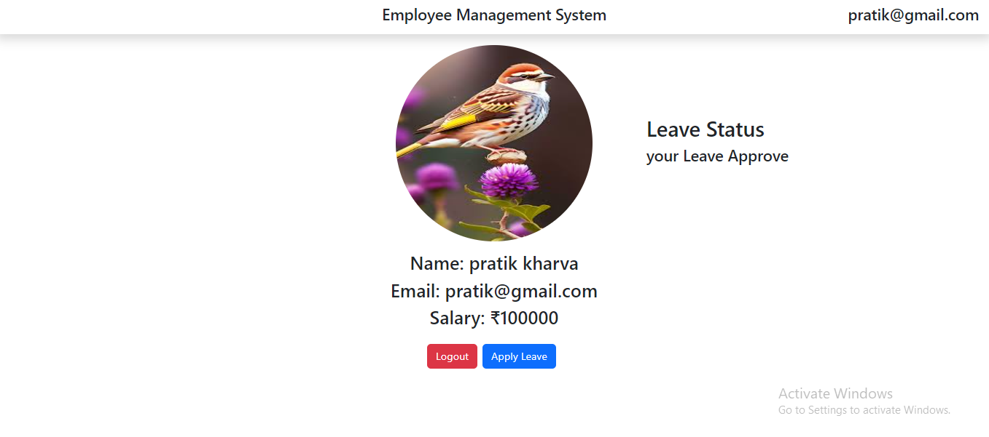

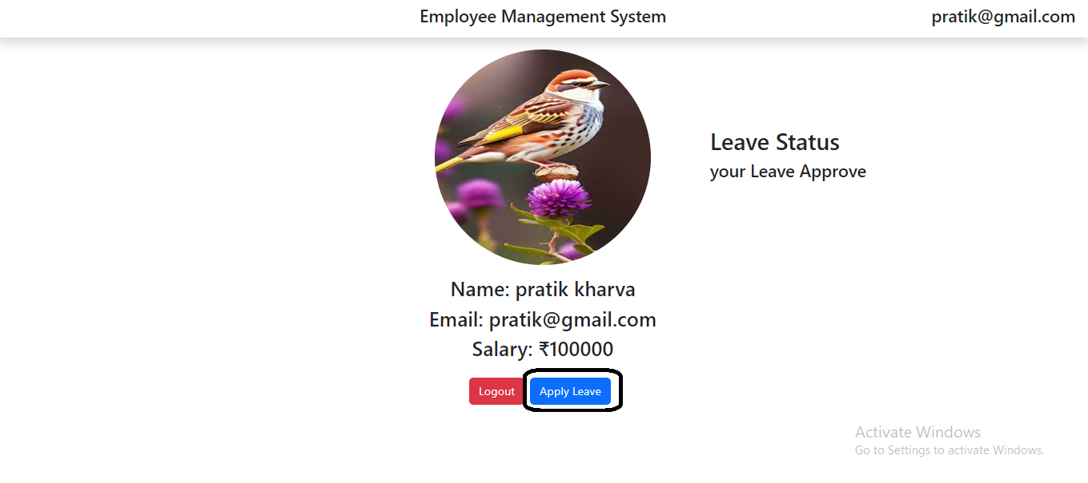

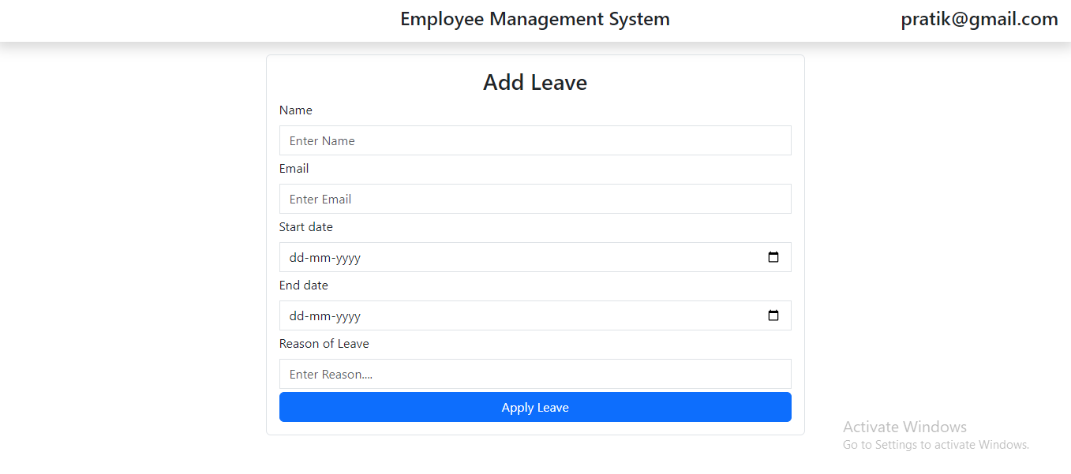

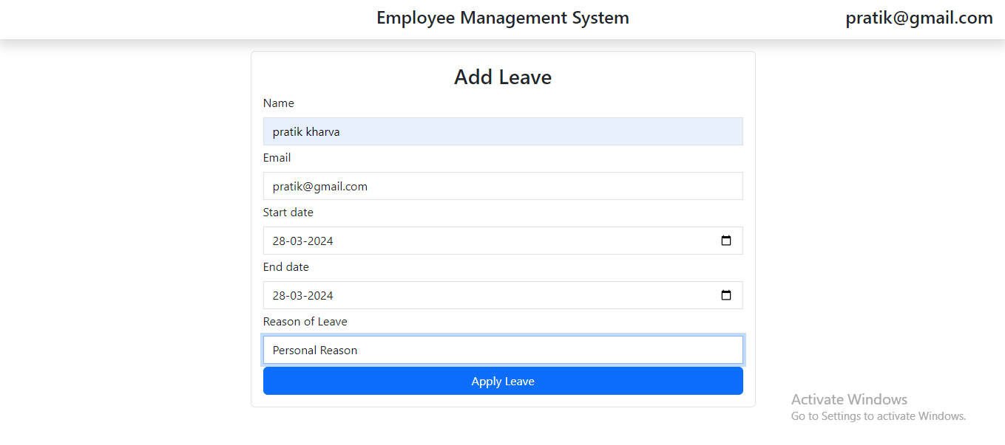

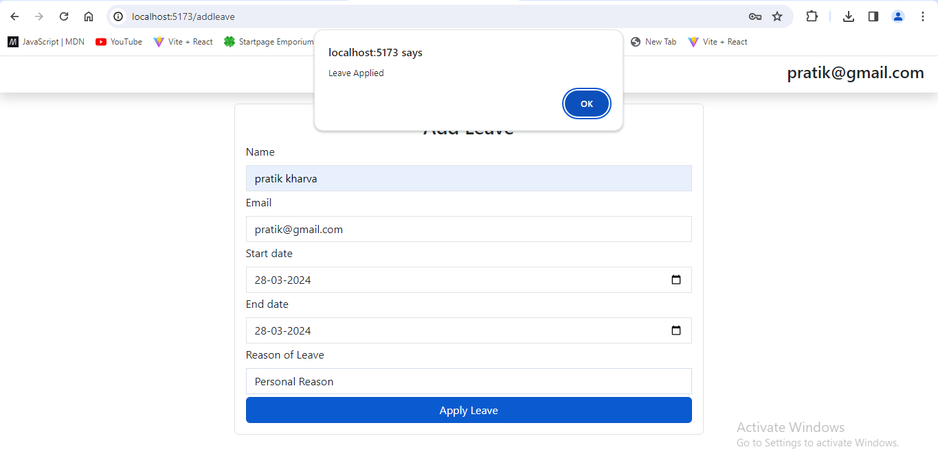

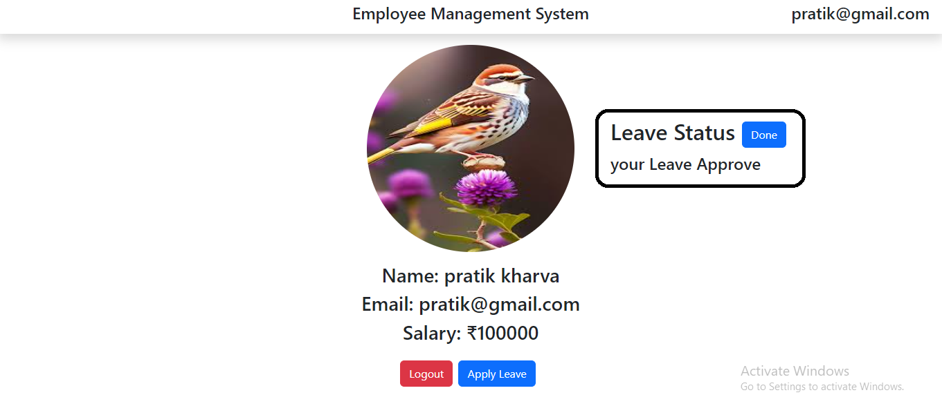

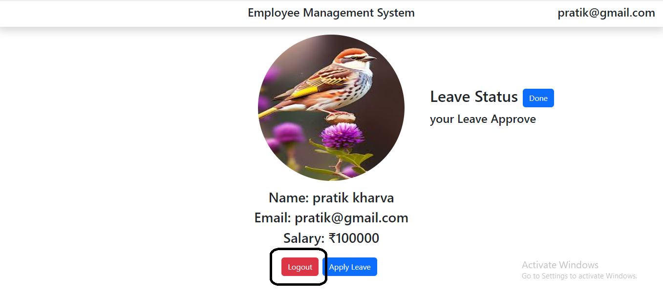

**Admin Module**

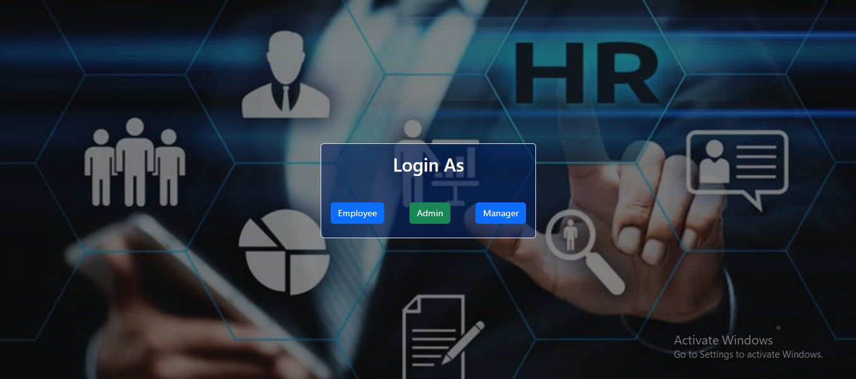

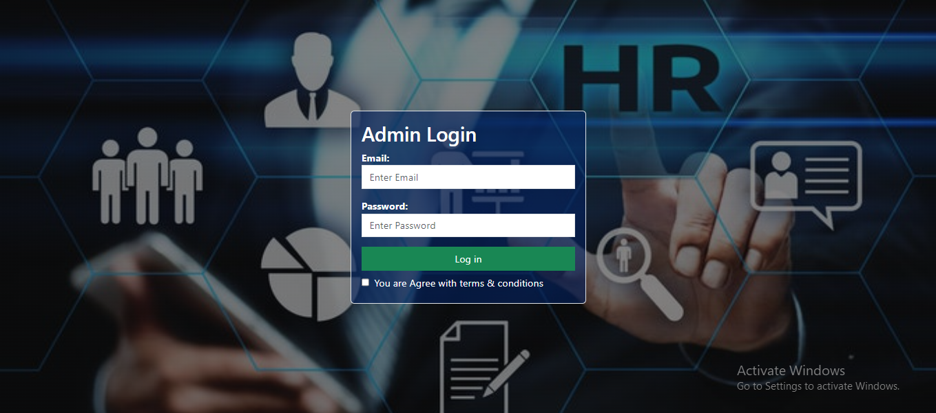

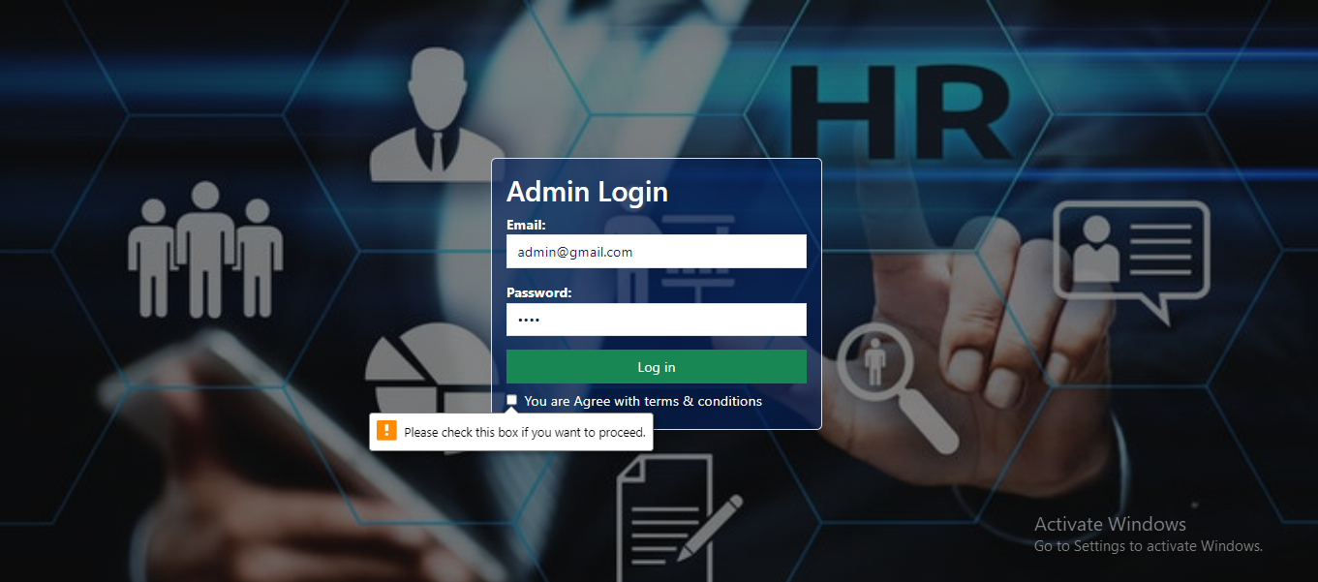

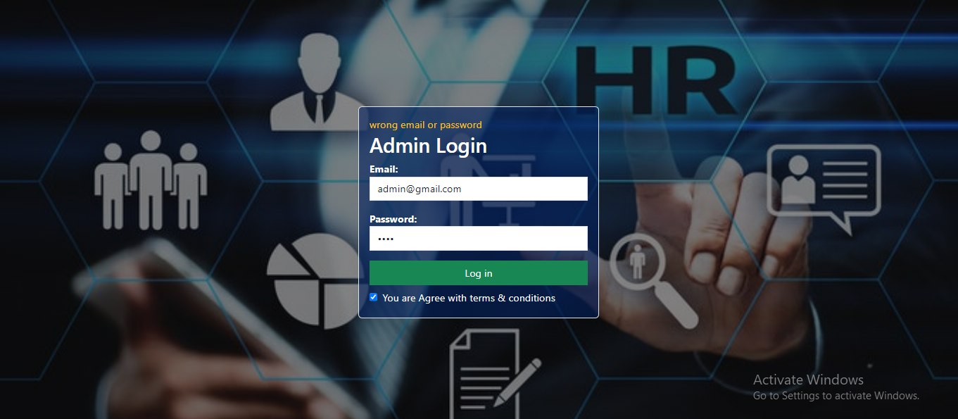

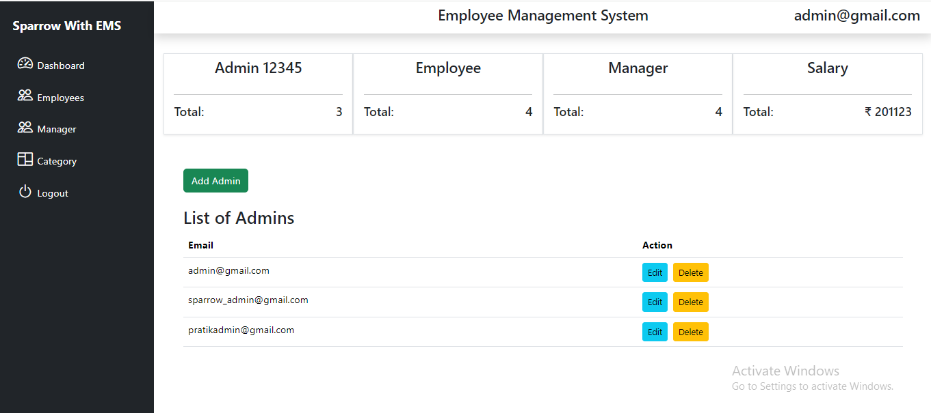

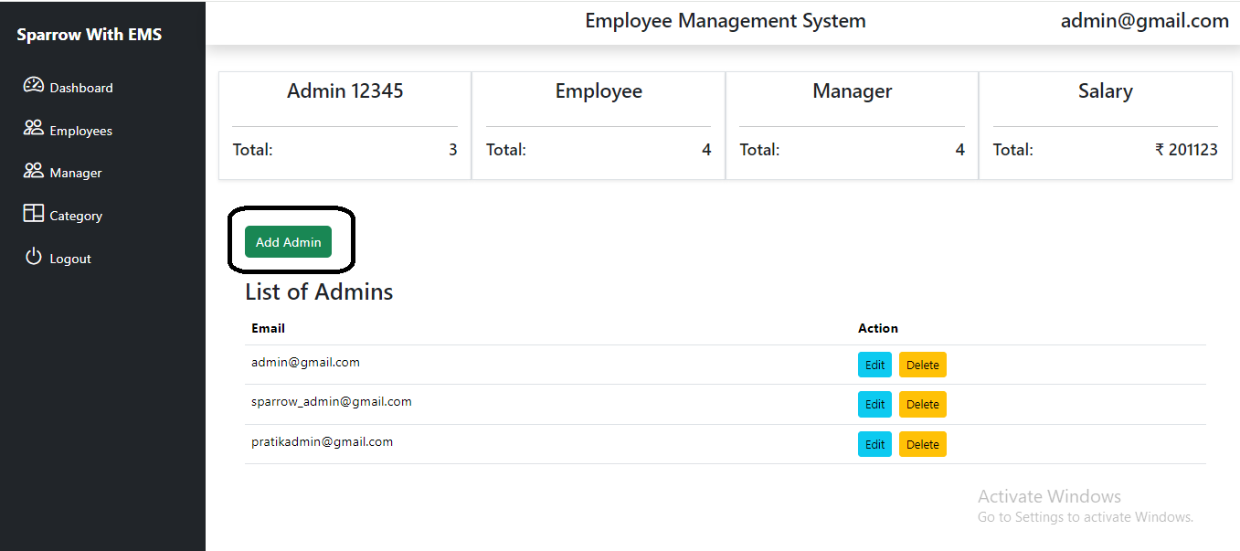

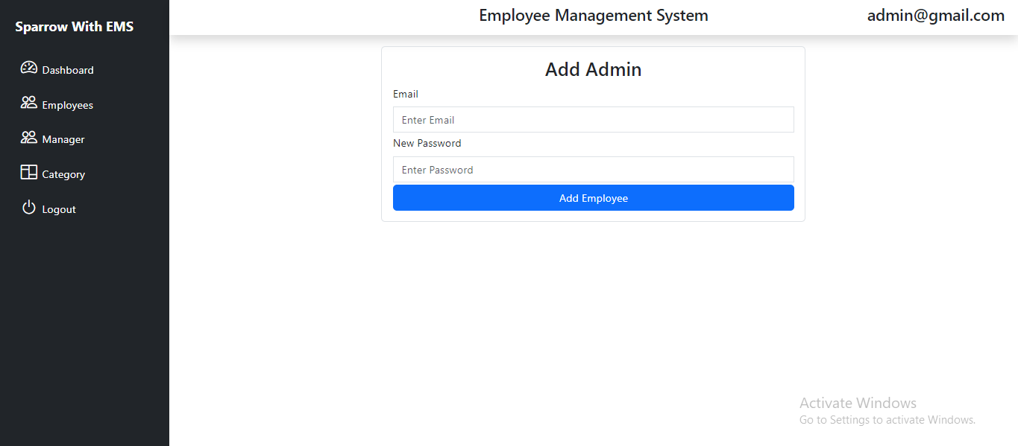

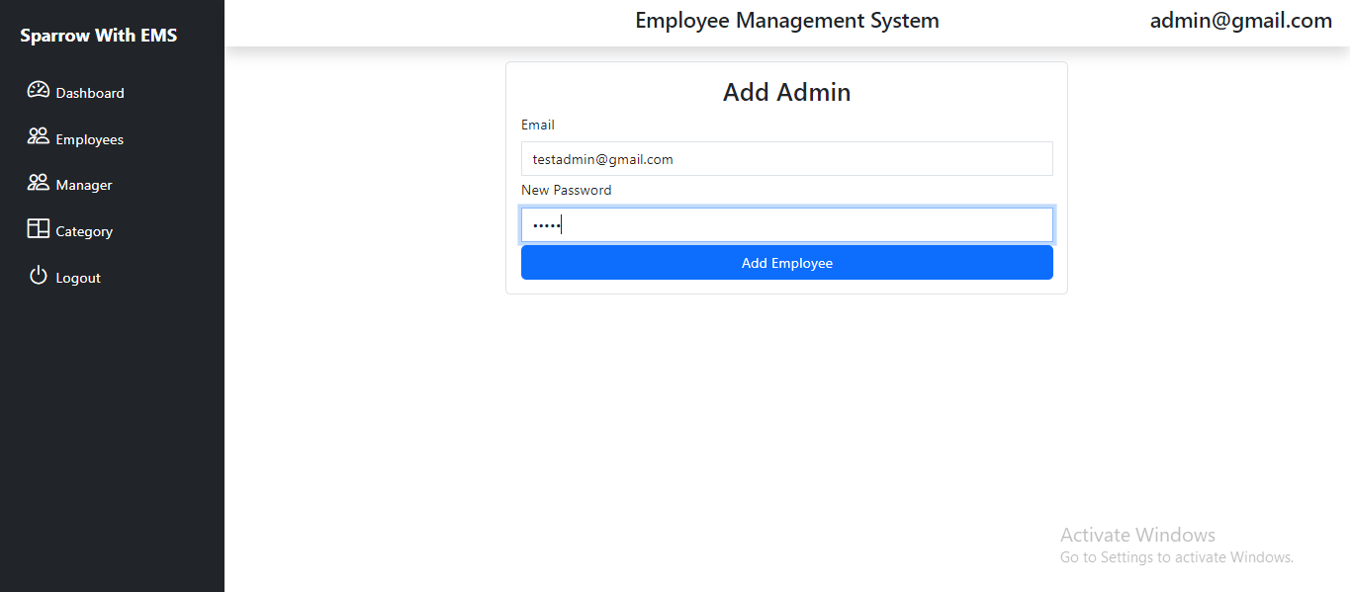

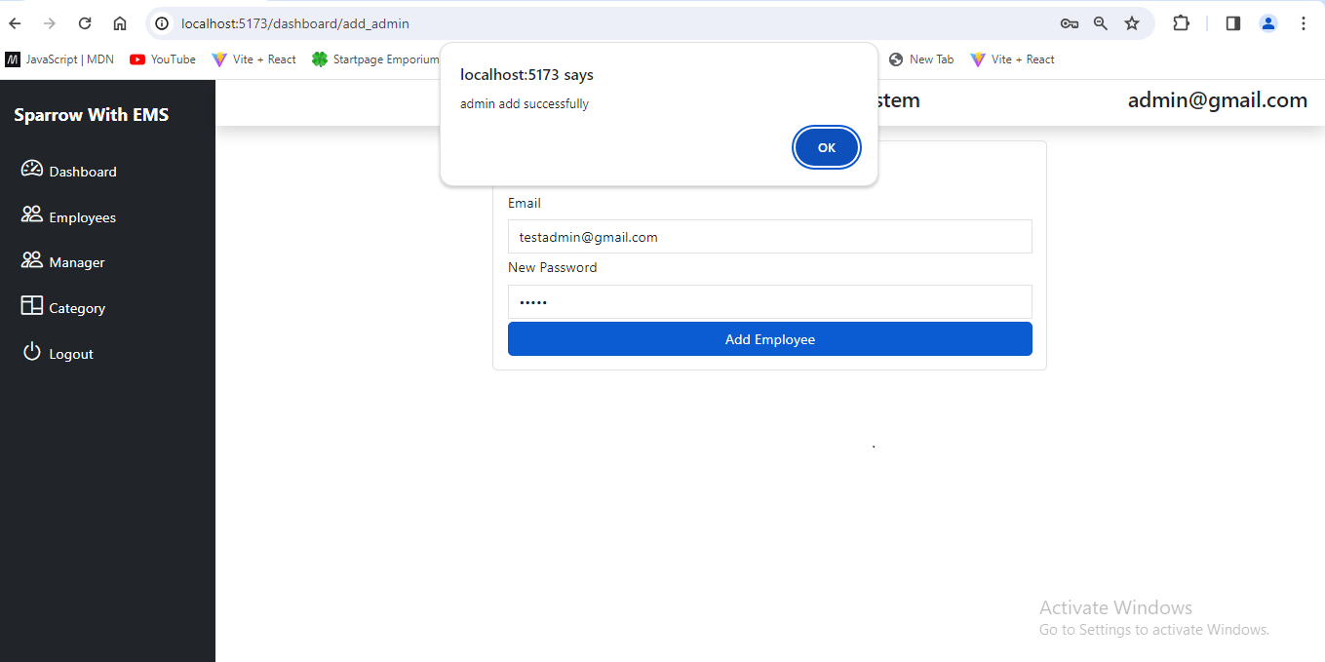

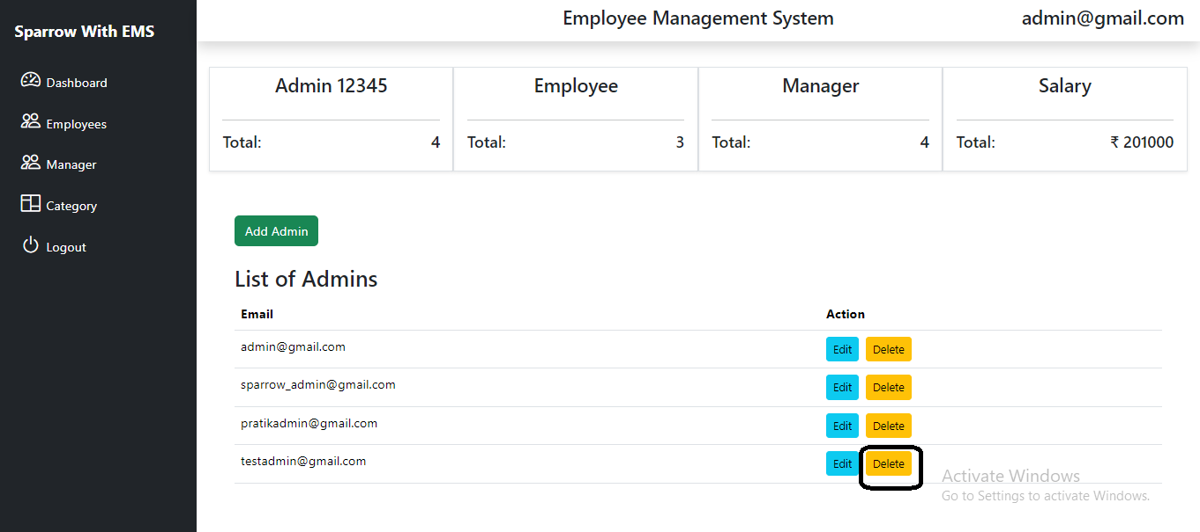

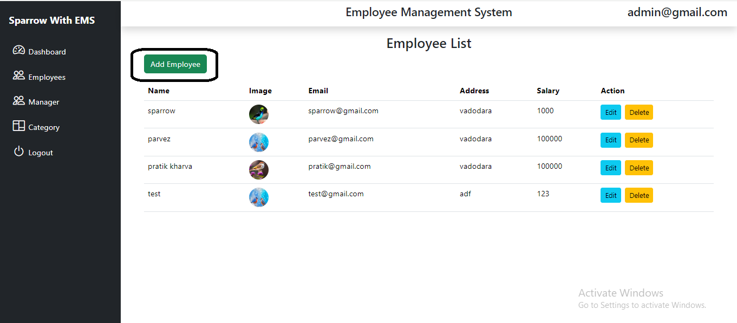

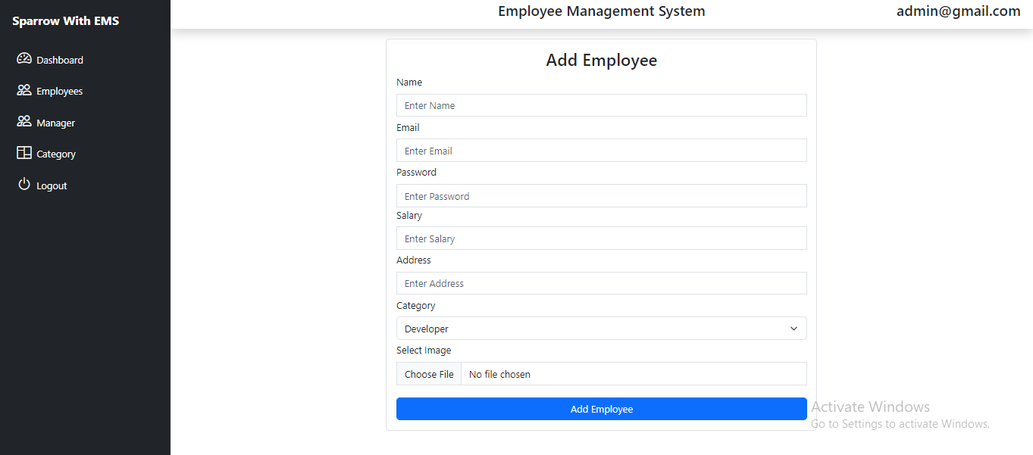

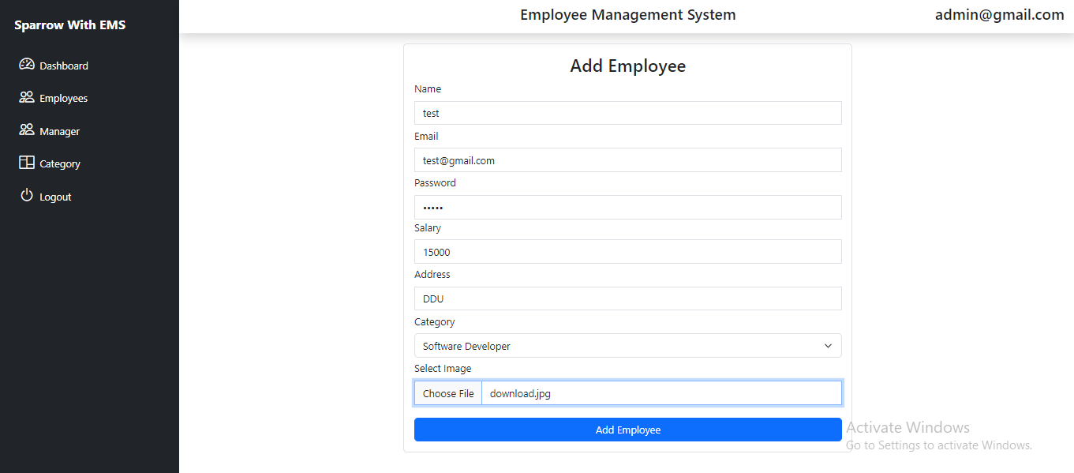

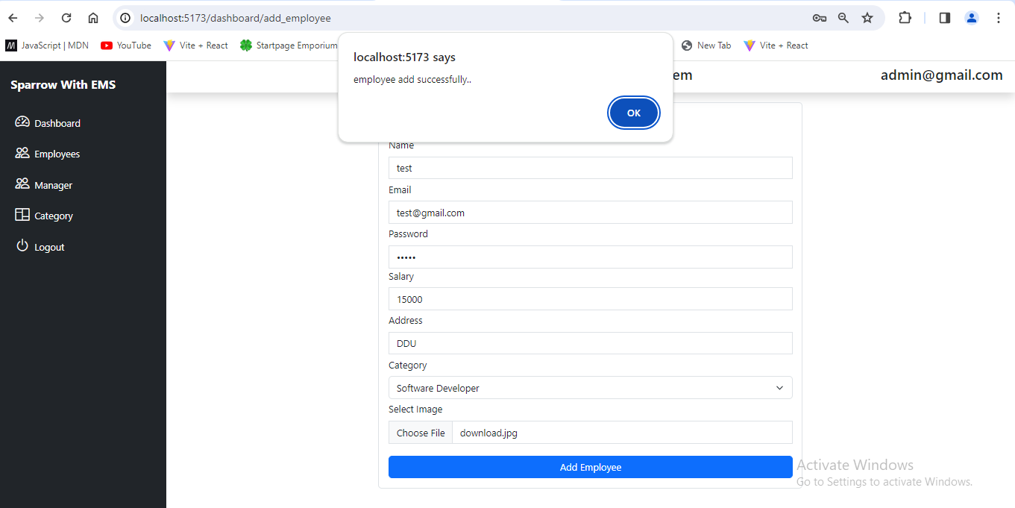

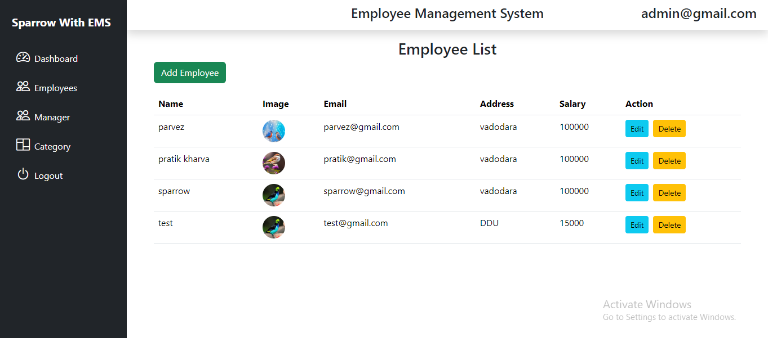

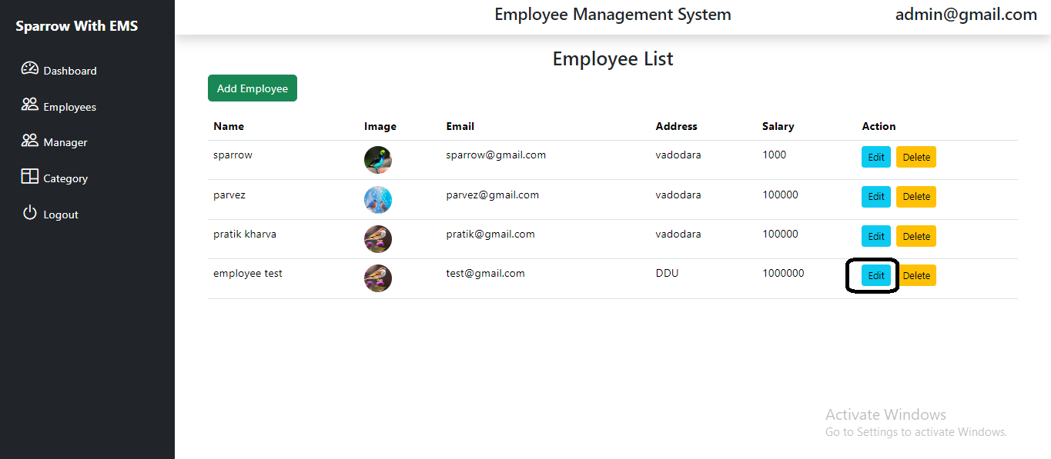

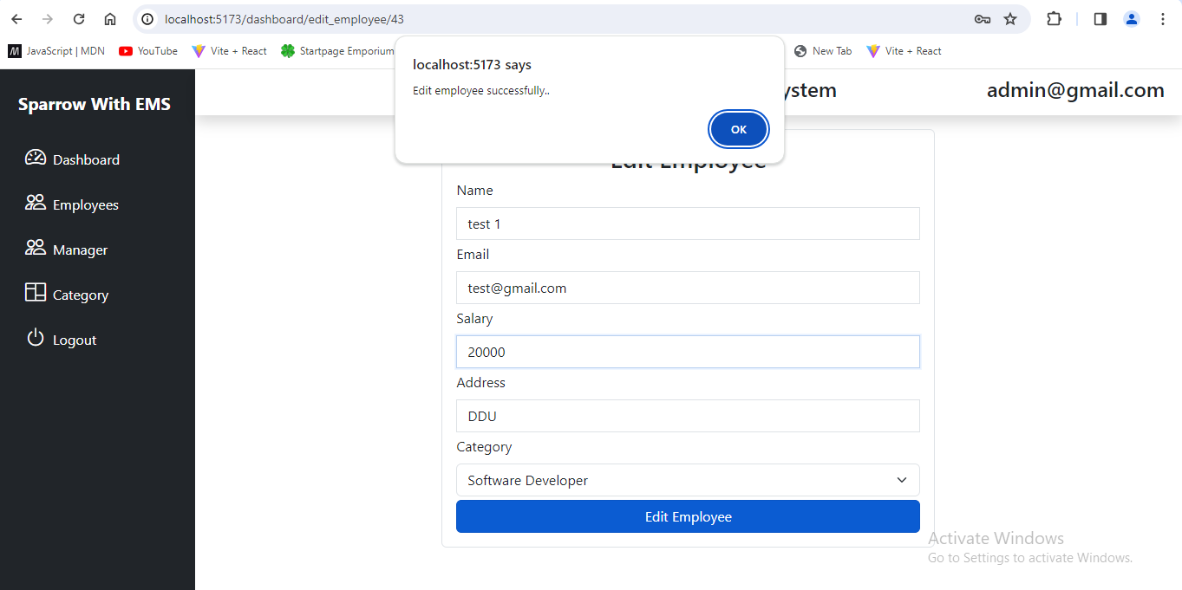

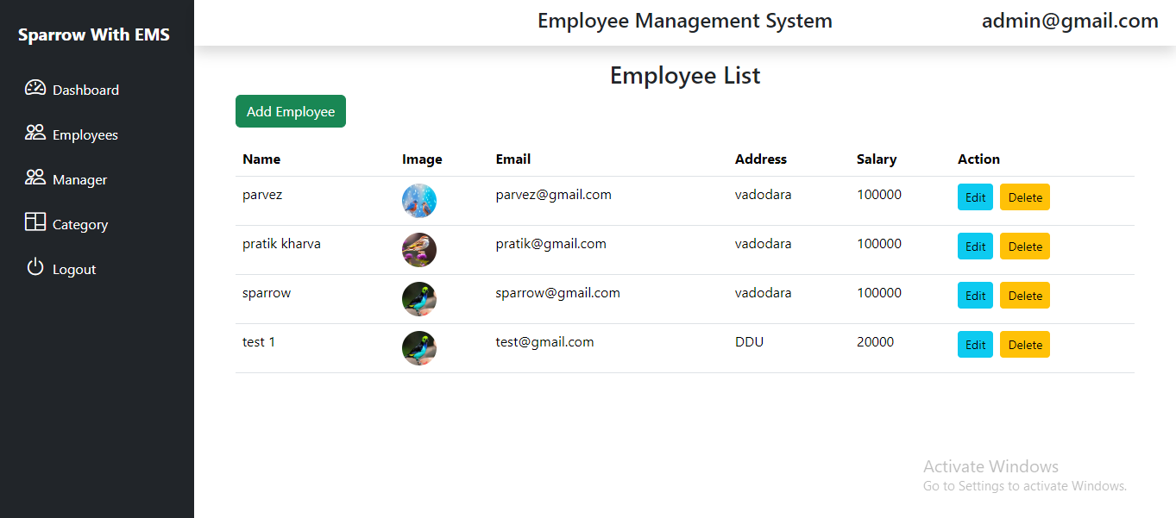

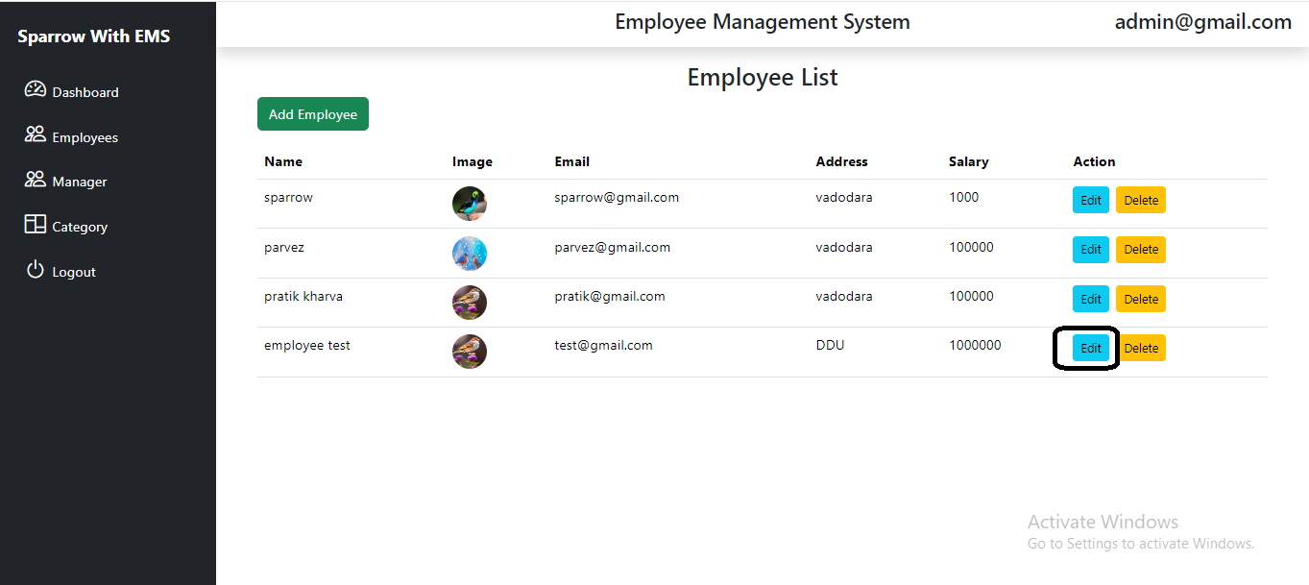

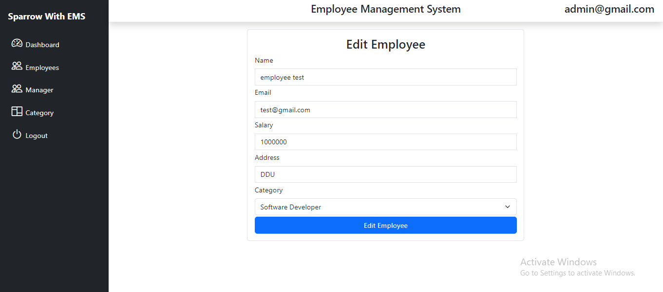

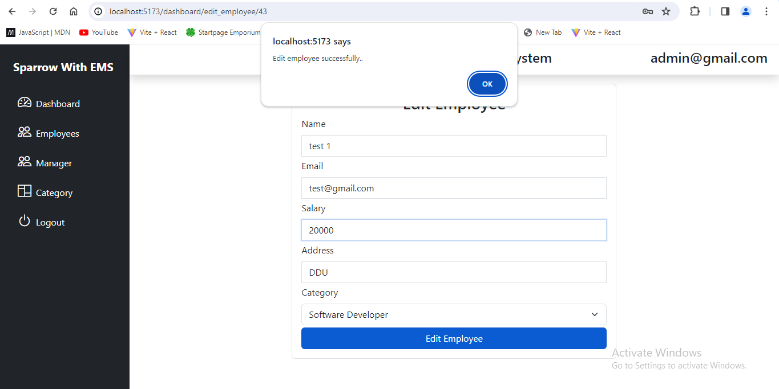

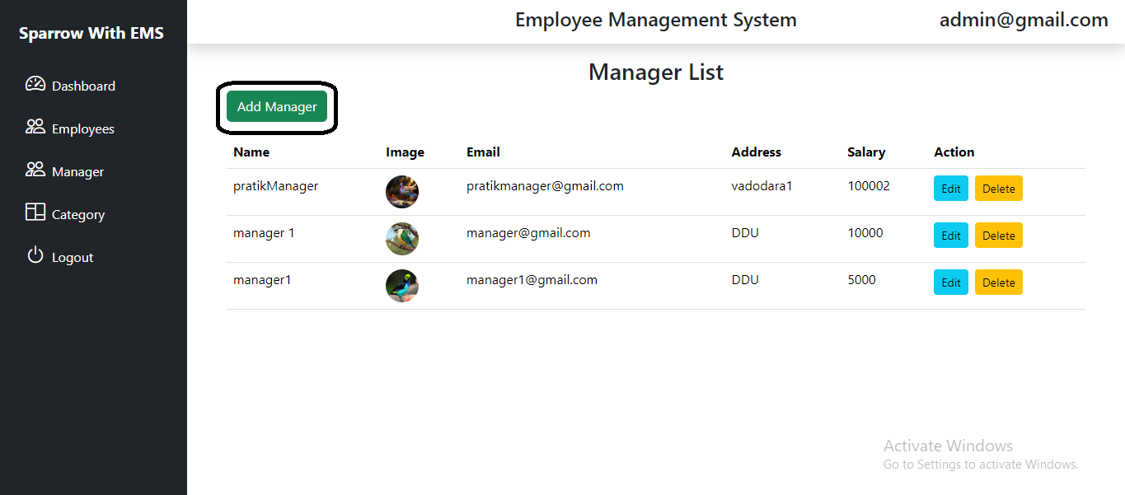

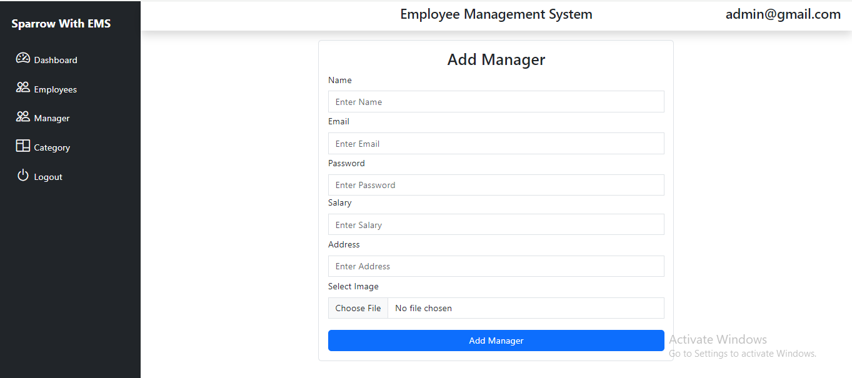

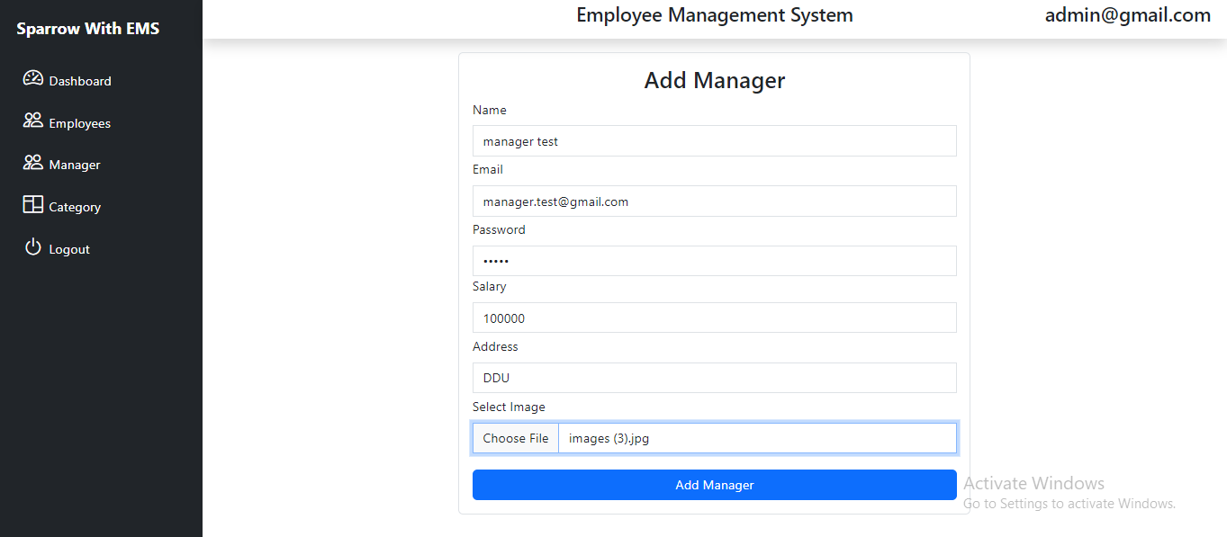

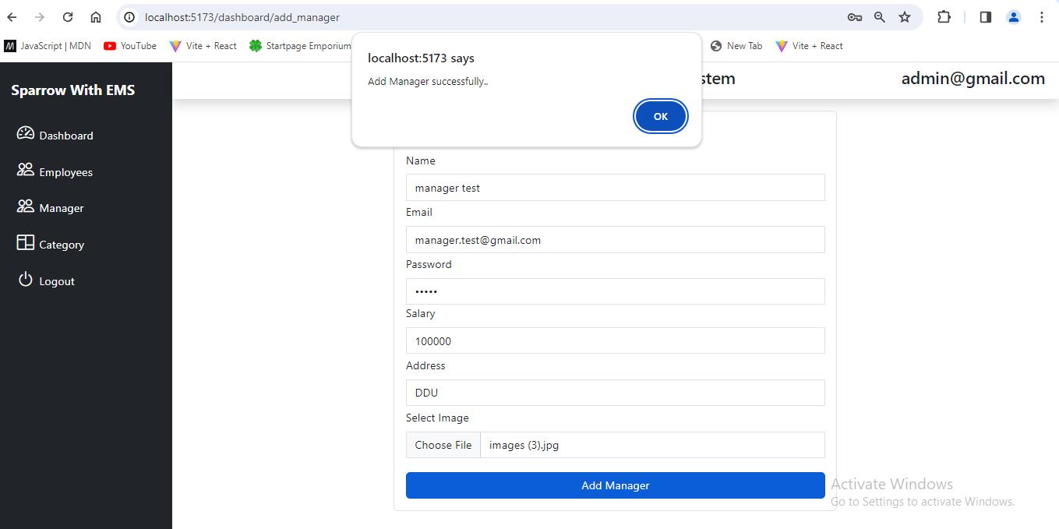

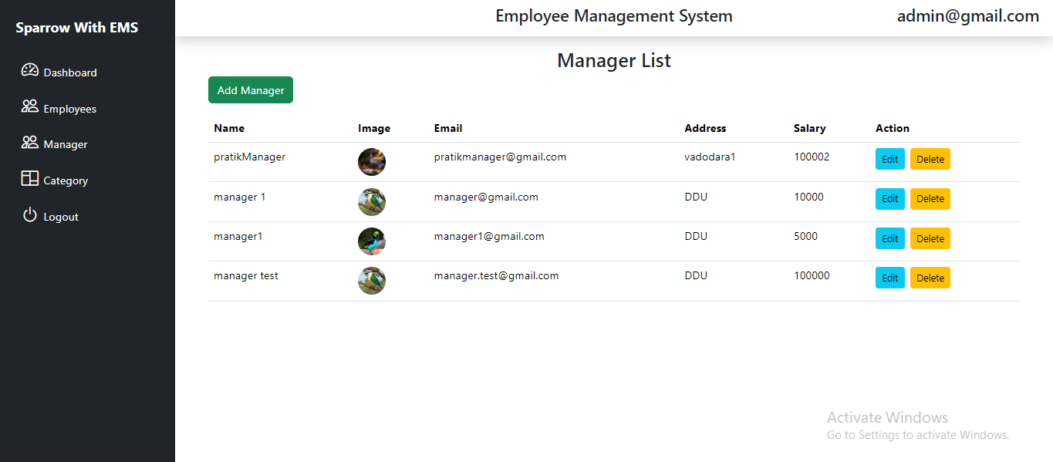

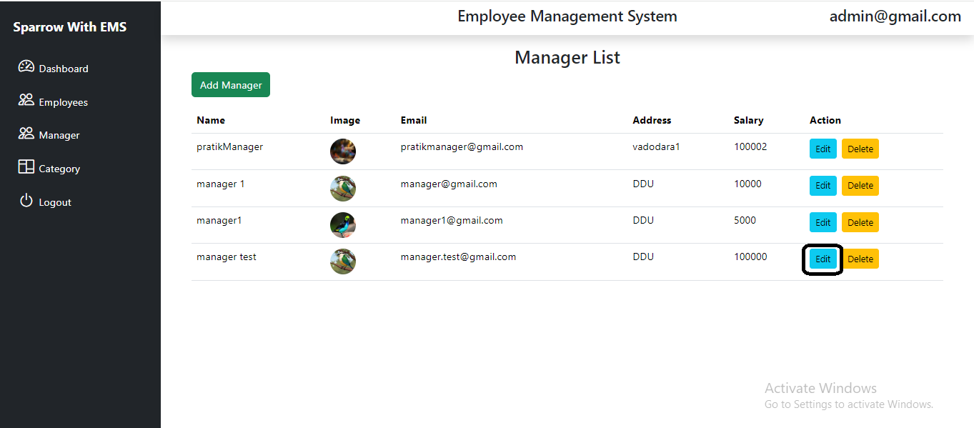

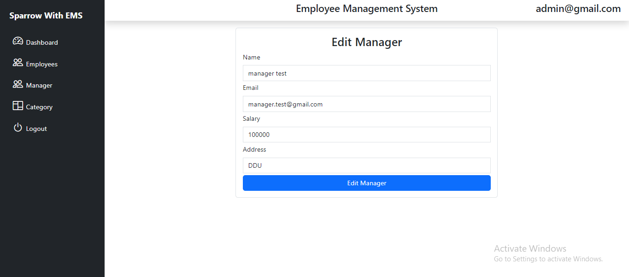

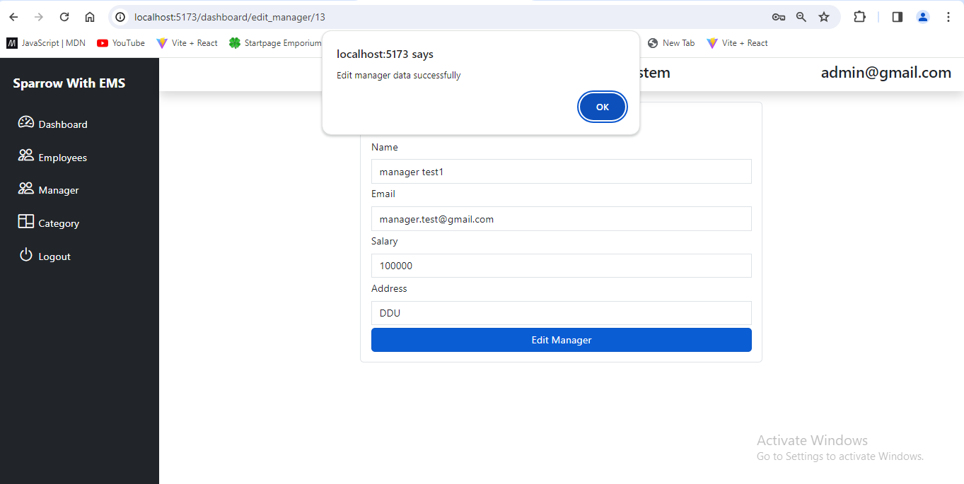

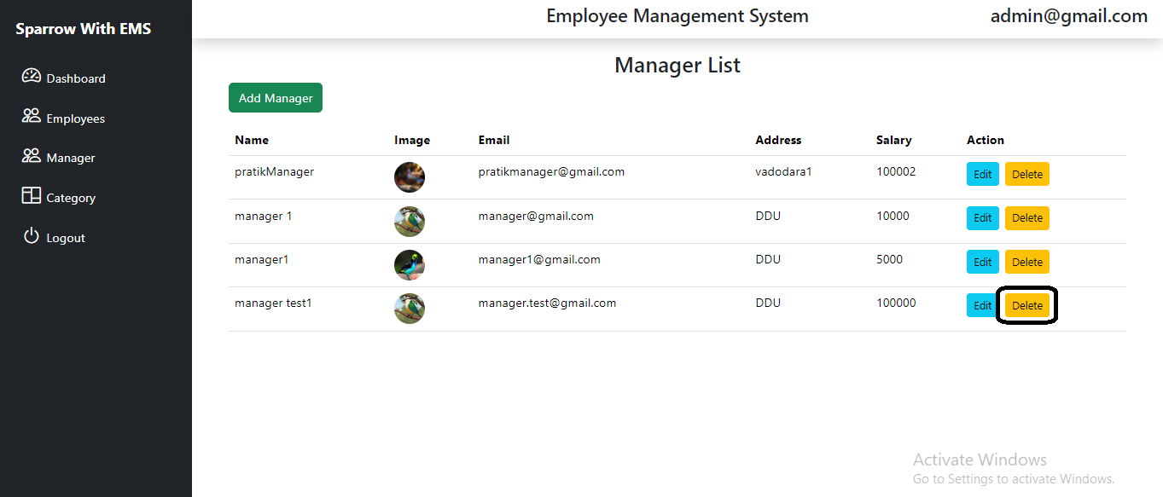

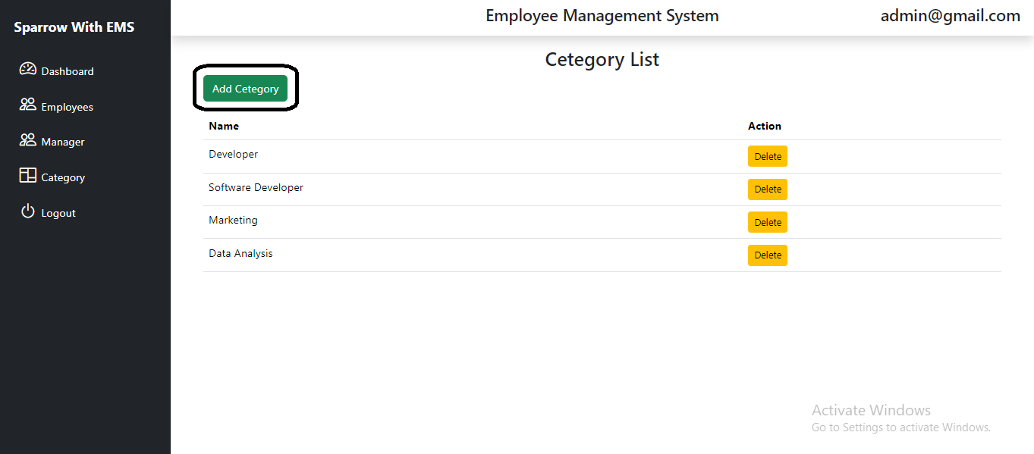

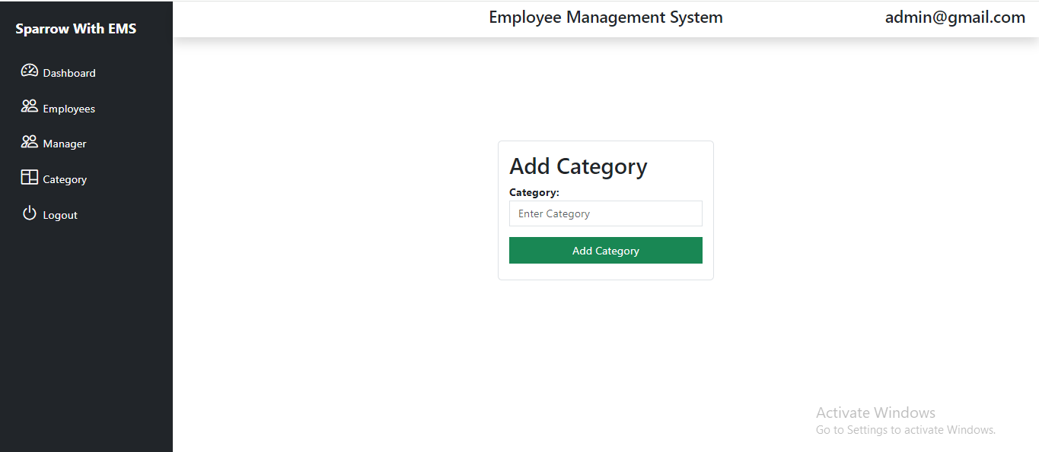

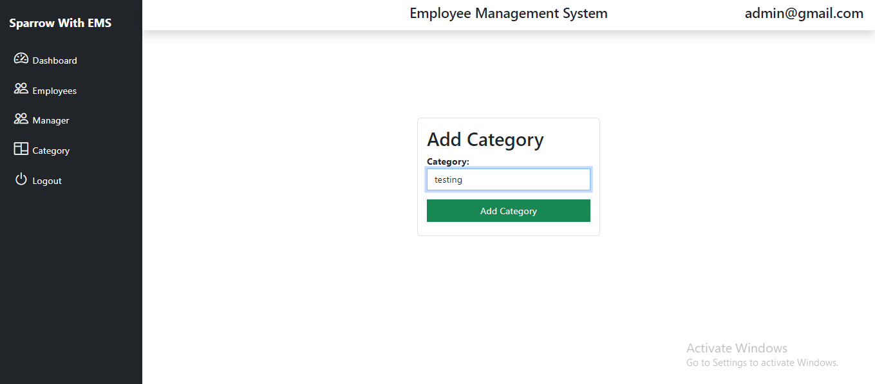

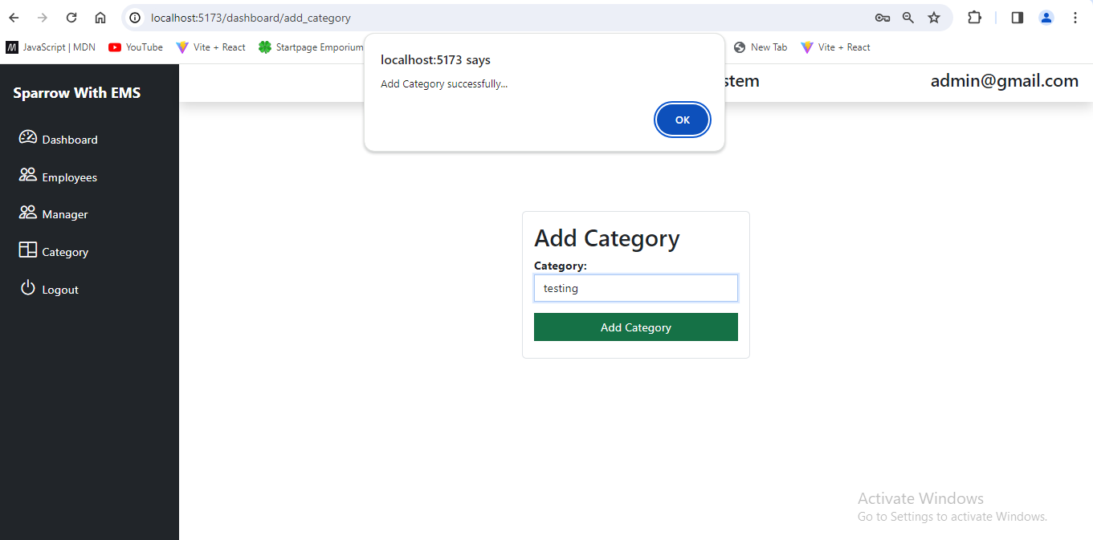

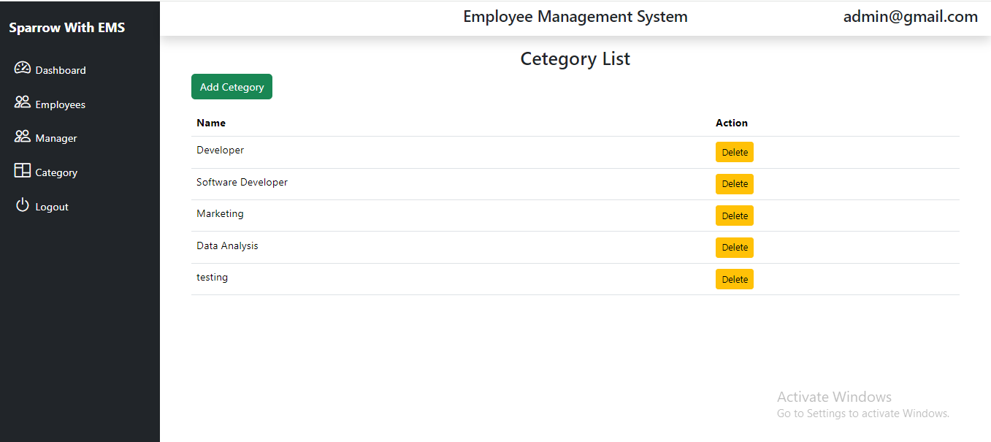

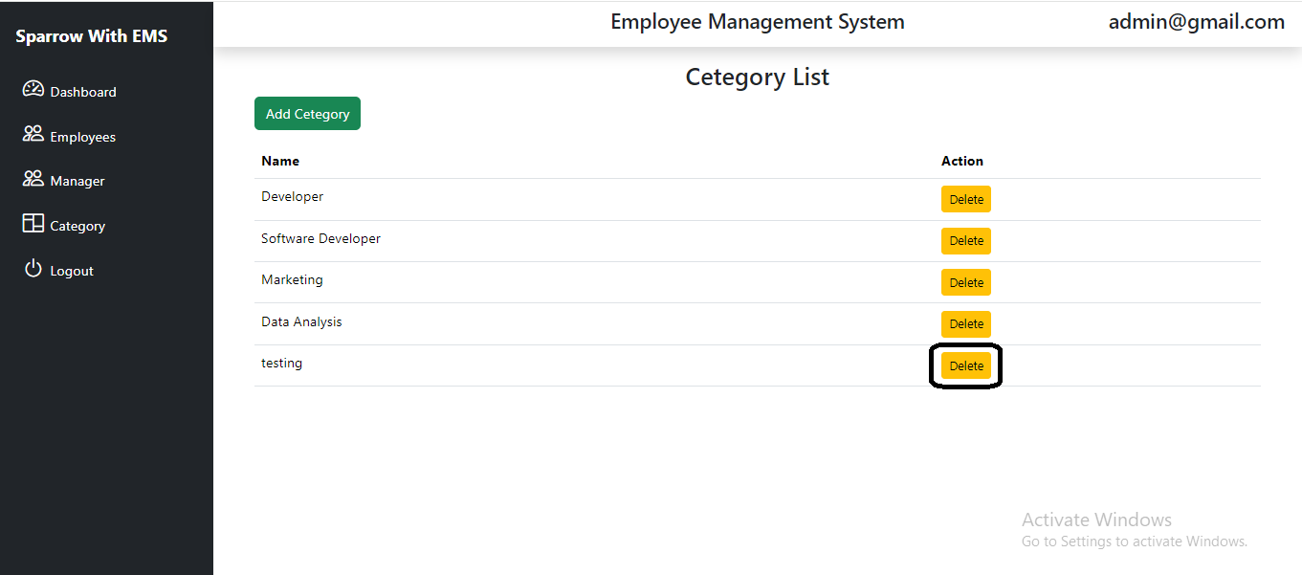

**Manager Module**

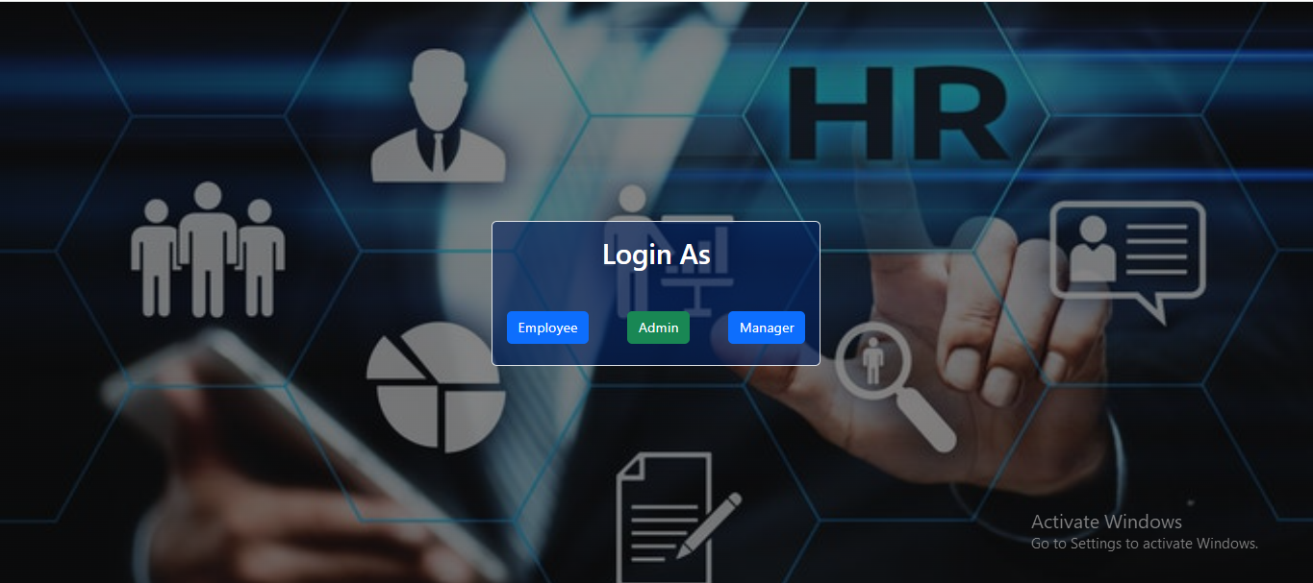

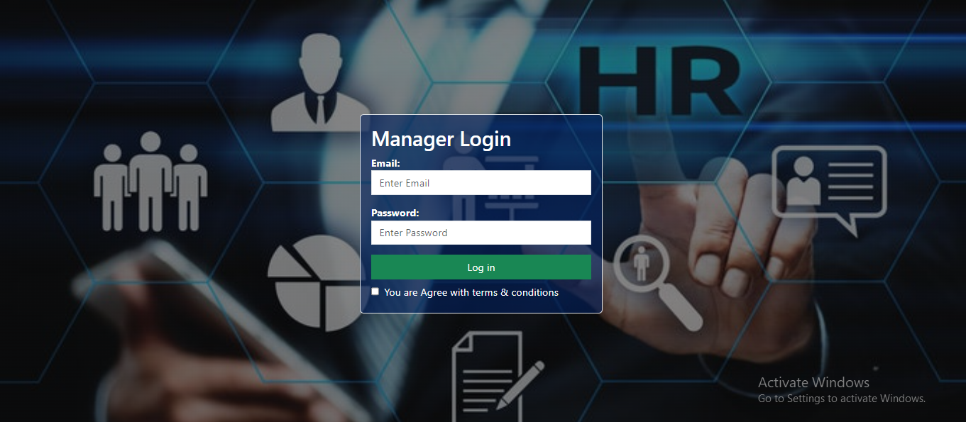

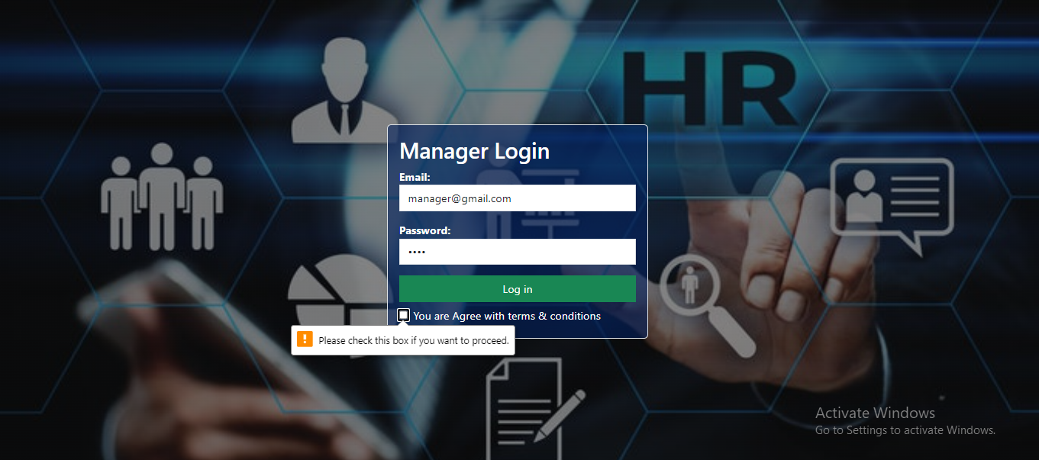

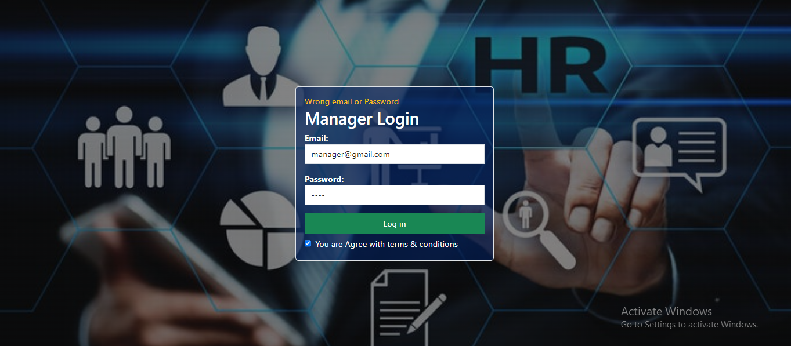

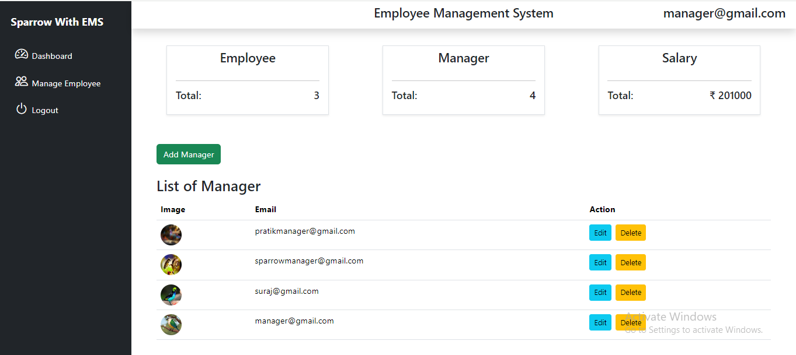

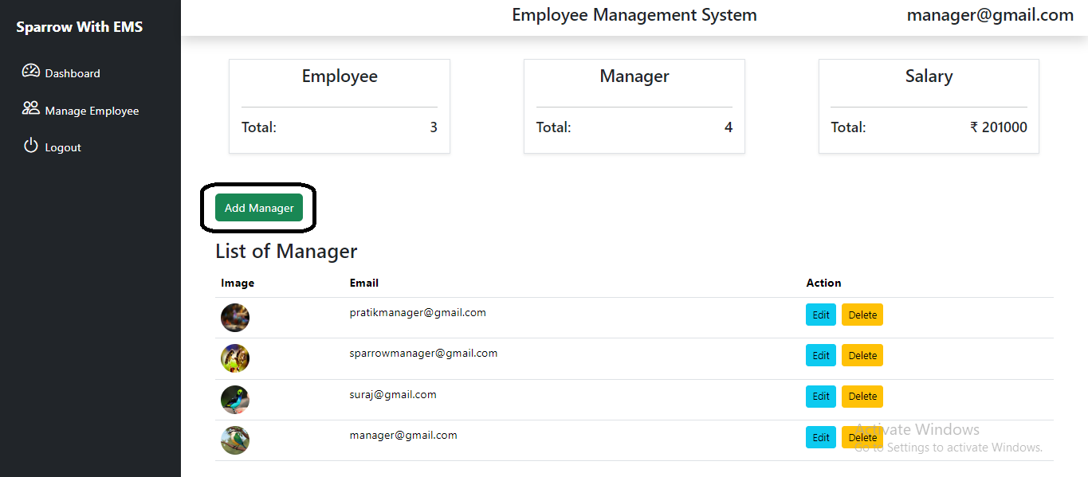

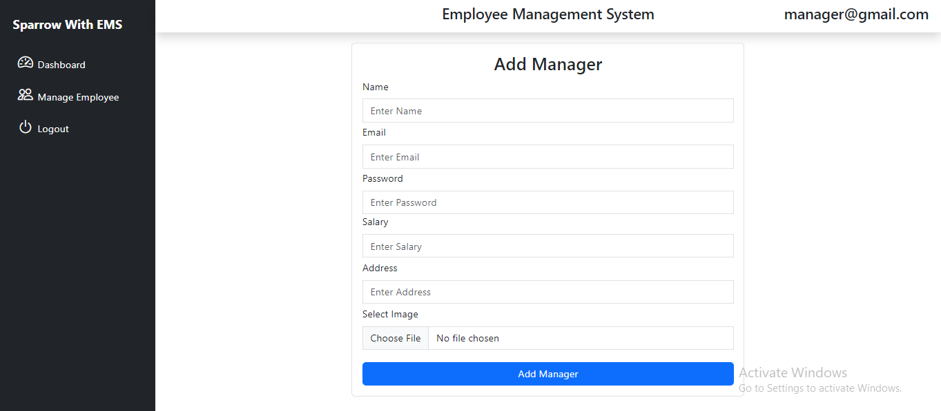

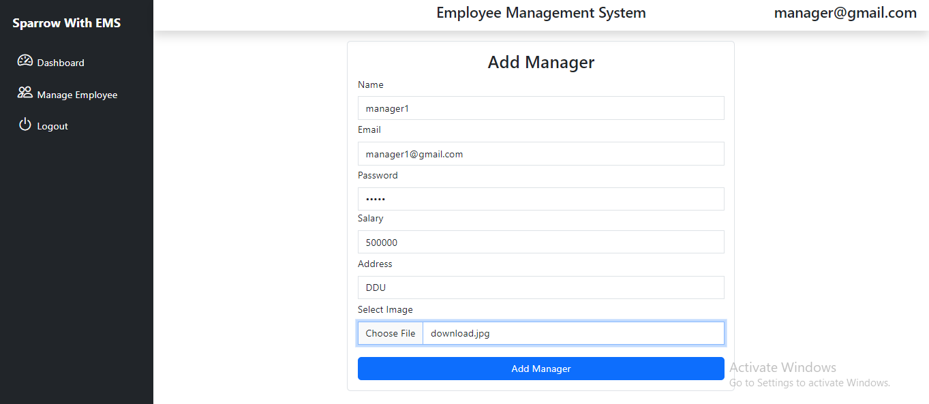

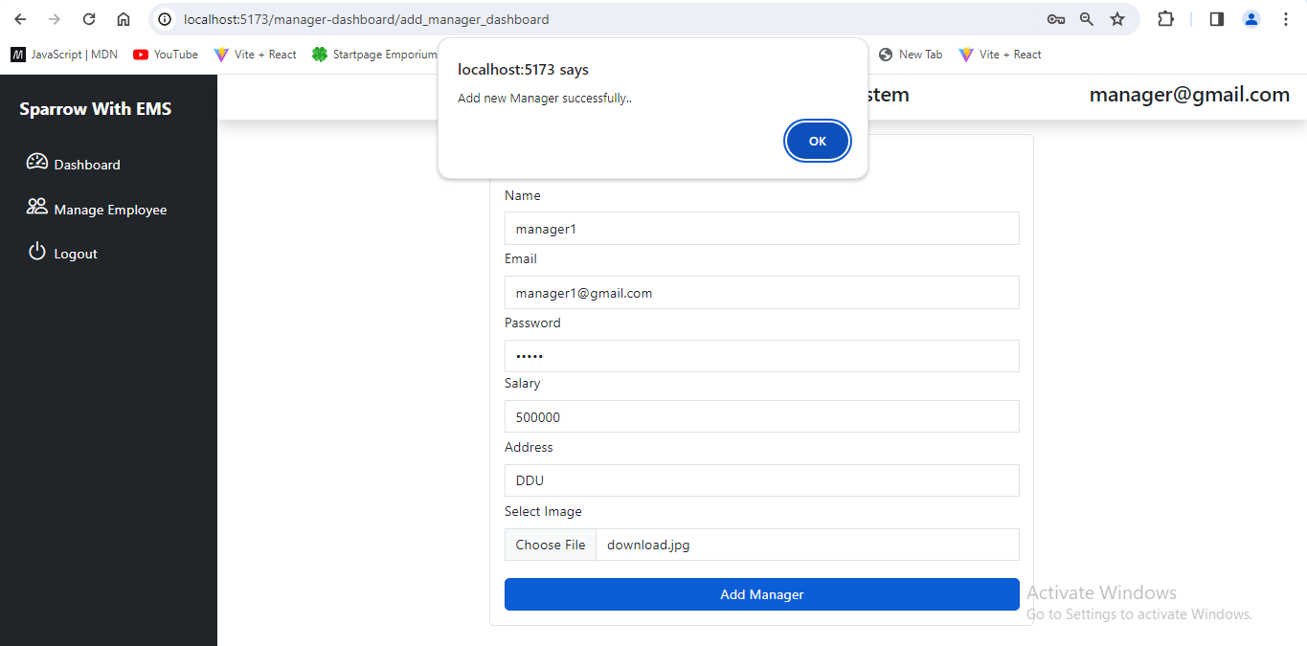

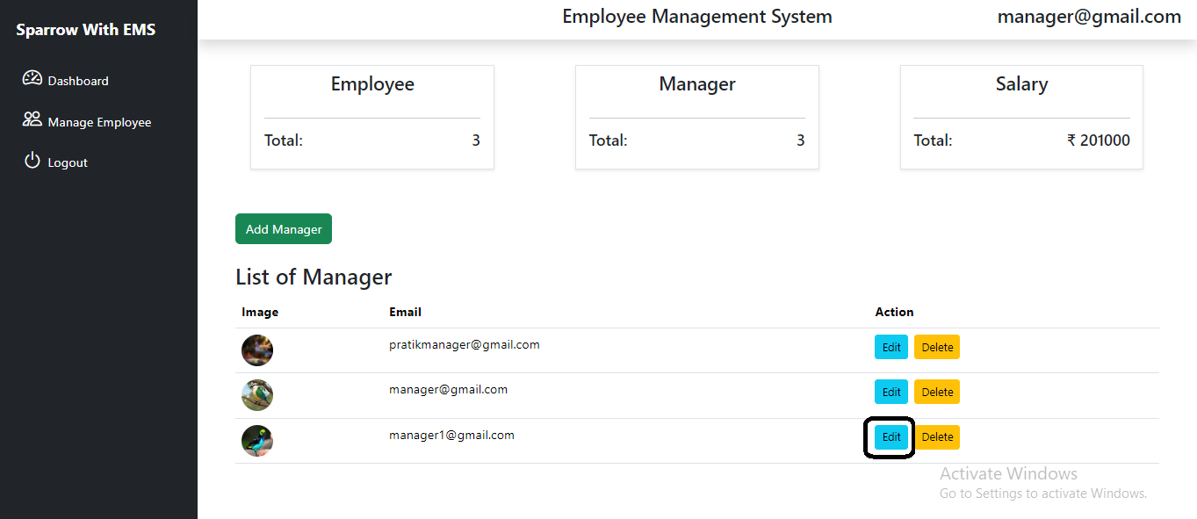

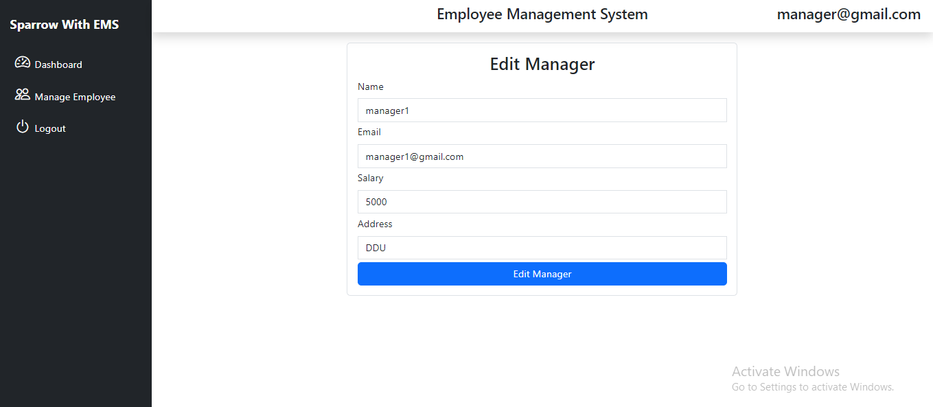

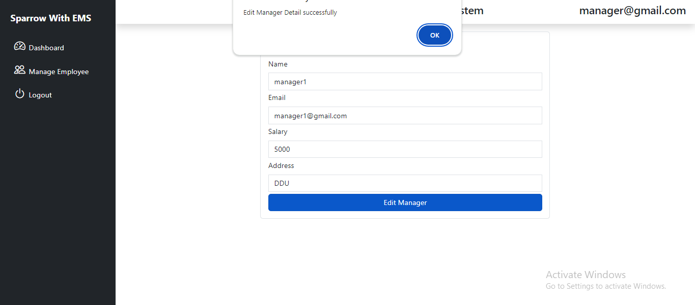

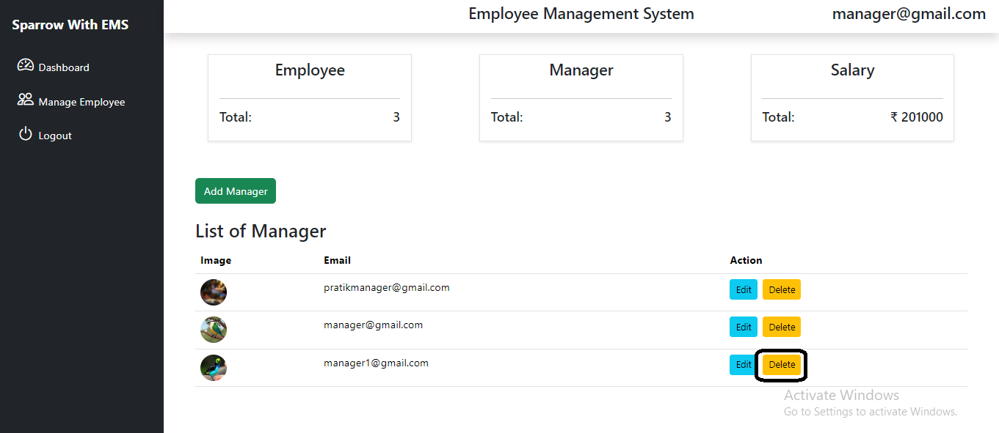

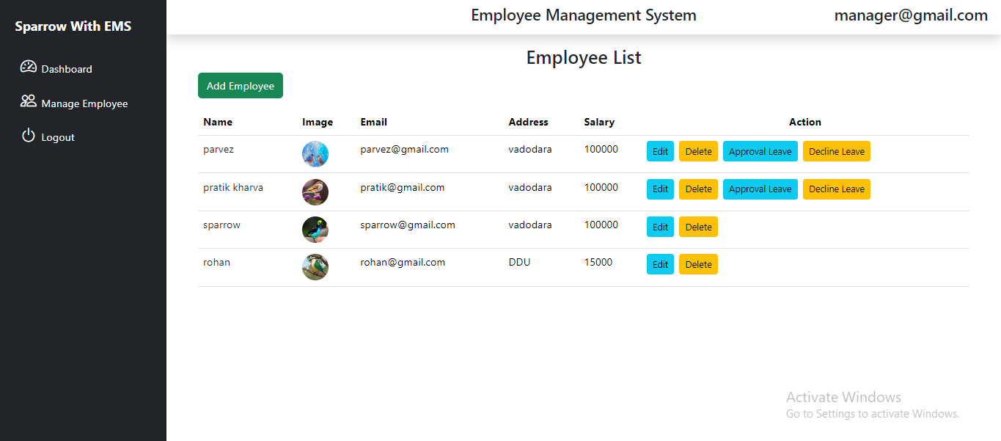

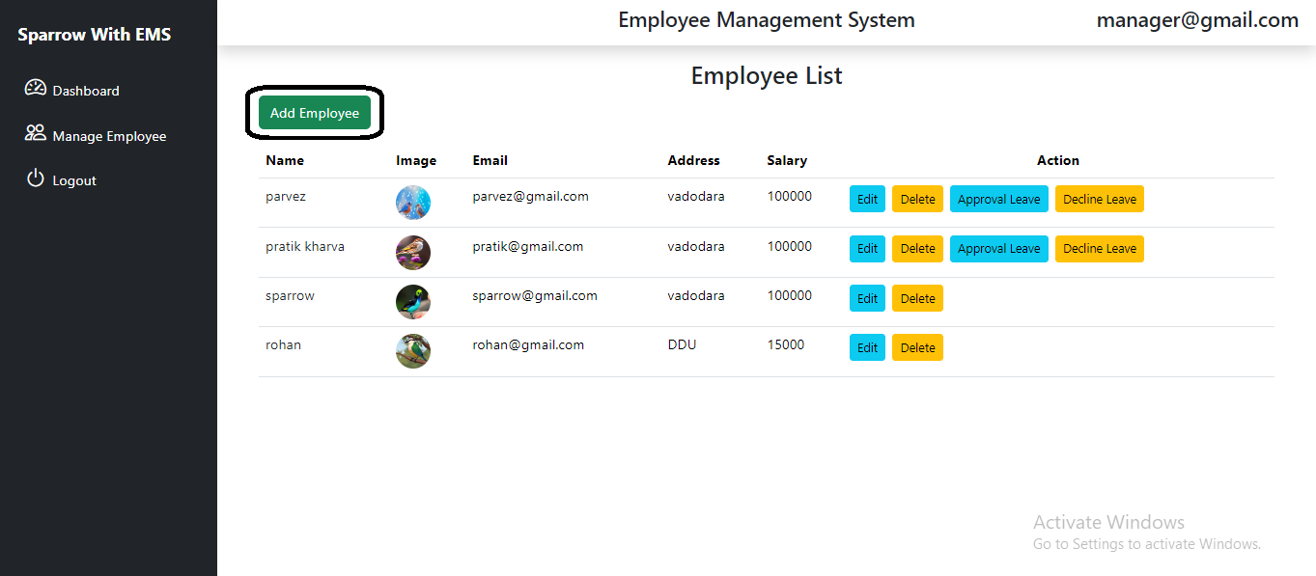

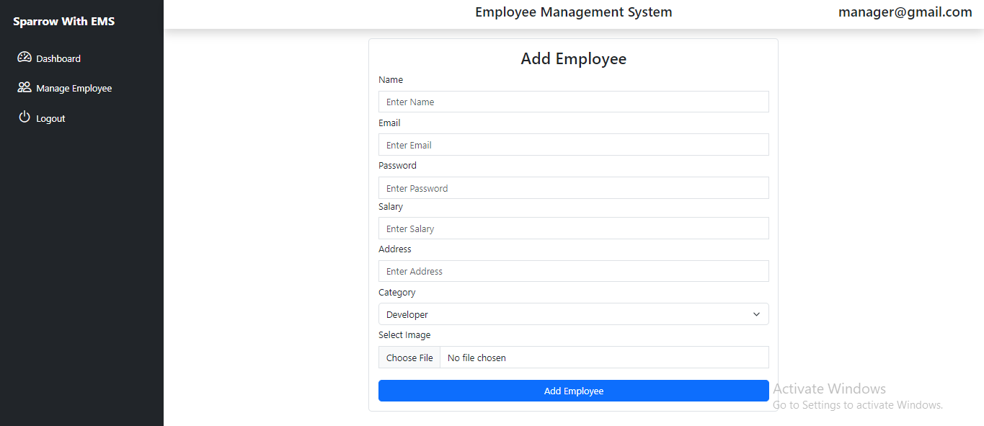

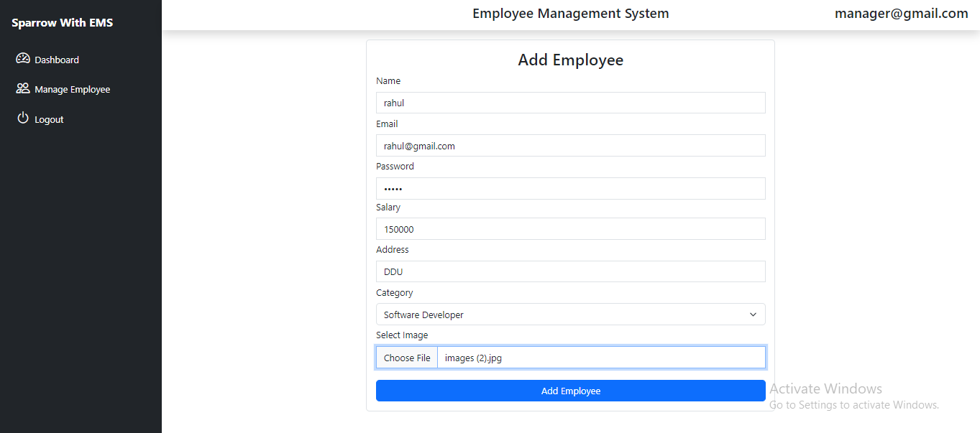

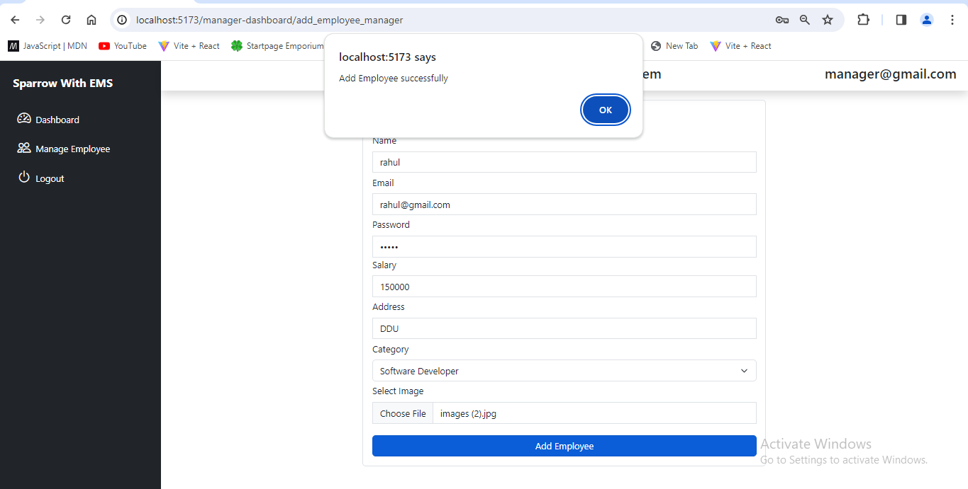

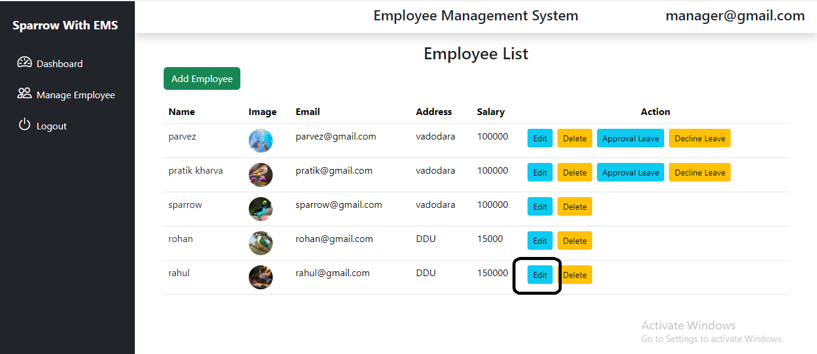

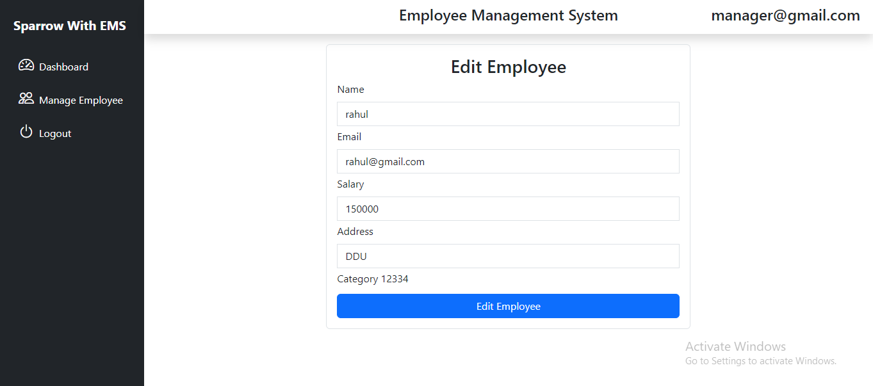

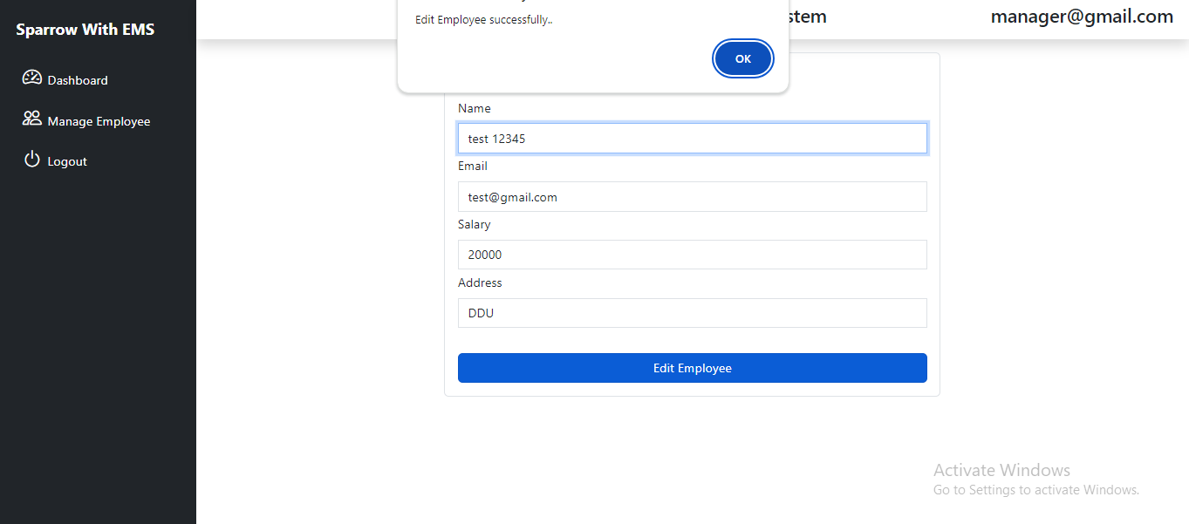

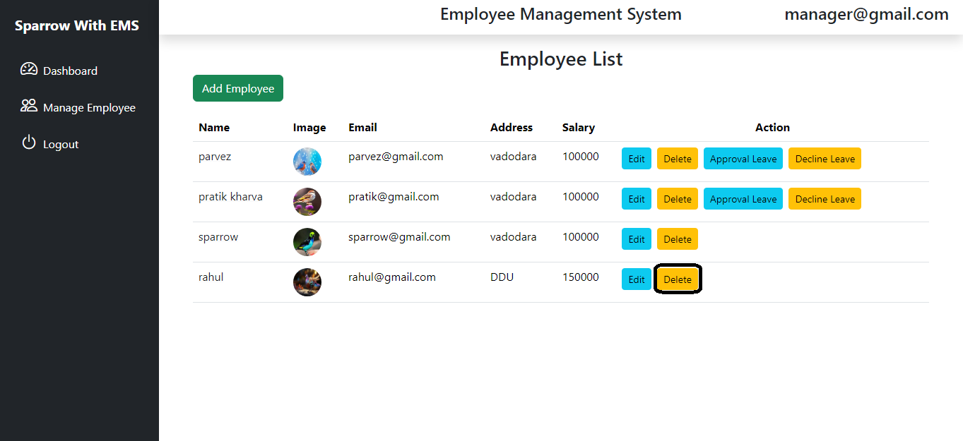

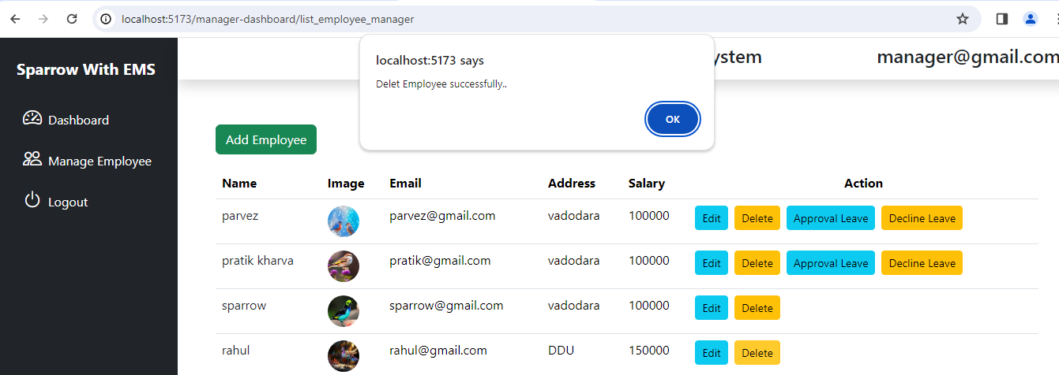

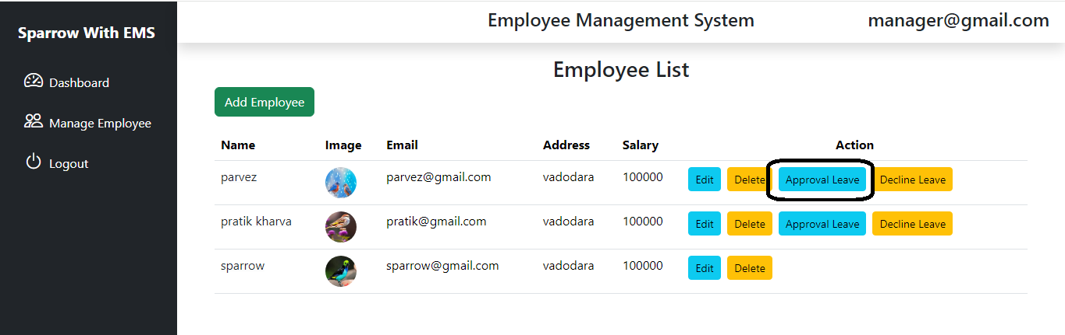

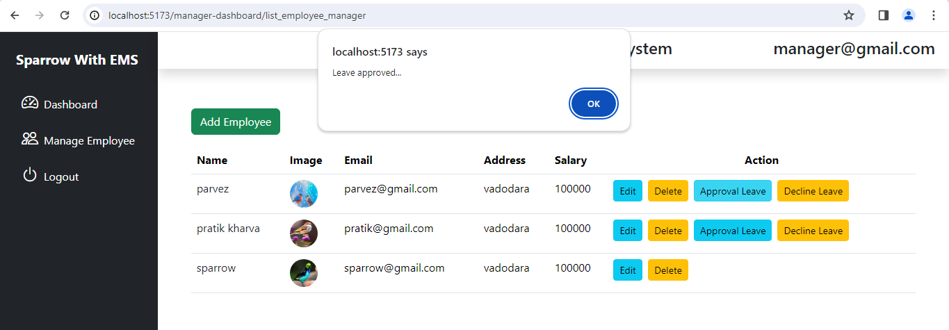

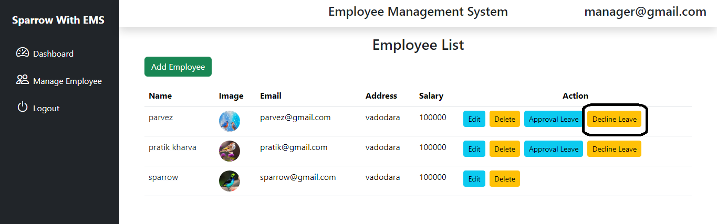

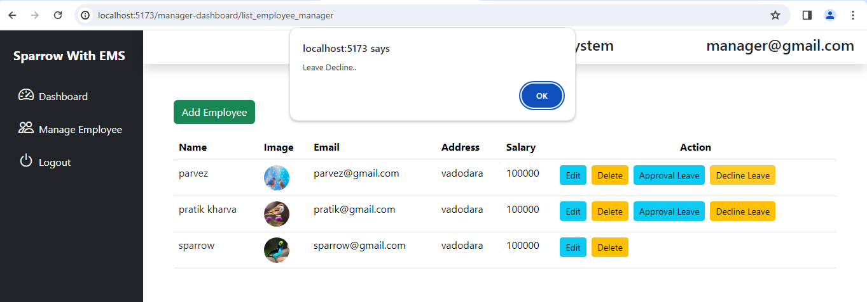

* 1. **Testing**
     1. **Test Strategy**

An employee management system or EMS is a tool that helps improve employee satisfaction and productivity to help a company achieve their overall goals. These tools help monitor, assess and control employees' working hours and efficiently utilize human resources. It ensures that Manager efficiently manages each employee's and disburses salaries on time. An EMS securely stores and manages the personal and work-related details of employees. So, while checking Test cases I have use ‘Unit test strategy’ where analysing various artefacts taken place. It includes employee management requirements, design, manage employee profile data, Leave management etc.

* + 1. **Test Cases and Results**

**Admin Test Cases**

|  |  |  |  |  |  |  |
| --- | --- | --- | --- | --- | --- | --- |
| **S.r.**  **no.** | **Description** | **Test steps** | **Expected result** | **Example** | **Actual status** | **Result** |
| 1. | Admin Verify Login page | Start System | Log in page display | Credentials. [admin@gmail.com](mailto:admin1@gmail.com)  admin@12345 | Login page displayed | Pass |
|  |  | Enter valid credentials | User logged in successfully |  | User logged in successfully |  |
|  |  | Click on log in button | Employee Dashboard displayed |  | Employee Dashboard displayed |  |
| 2. | Add Admin | Start system | Log in page display | New Admin | Login page display | Pass |
|  |  | Admin have to login | If authenticate Admin found , display Employee Dashboard |  | Employee Dashboard displayed |  |
|  |  | Click on ‘Add Admin’ button | Admin form displayed |  | Admin form displayed |  |
|  |  |  | Fill the form |  | Data filled |  |
|  |  | Click on ‘Add admin’ button | Admin added to the Admin list |  | Admin added to the Admin list |  |
| 3. | Edit Admin | Start system | Login page display | Edit Admin | Login page display | Pass |
|  |  | Admin have to login | If authenticate Admin found , display Employee Dashboard |  | Employee Dashboard displayed |  |
|  |  | Click on ‘Edit Admin’ button | Edit Admin form displayed |  | Edit Admin form displayed |  |
|  |  |  | Fill the form |  | Data filled |  |
|  |  | Click on ‘Edit admin’ button | Admin Edited |  | Admin Edited |  |
| 4. | Add new Employee | Start System | Login page display | New Employee | Login page Displayed | Pass |
|  |  | Click on employees said Nev | Display employee list |  | Display employee list |  |
|  |  | Click on Add Employee button | Display add employee form |  | Display add employee from |  |
|  |  |  | Fill the form |  | Fill the form |  |
|  |  | Click add employee button | Add new employee |  | Add employee |  |
| 5. | Delete employee | Start system | Login page display | Delete Employee | Login page displayed | Pass |
|  |  | Click on employee said Nev | Display dashboard employee list |  | Display employee list |  |
|  |  | Click on delete button | Employee delete in to list |  | Employee delete in to list |  |
| 6. | Add new Manager | Start System | Login page display | New Manager | Login page Displayed | Pass |
|  |  | Click on employees said Nev | Display manager list |  | Display manager list |  |
|  |  | Click on Add manager button | Display add manager form |  | Display add manager from |  |
|  |  |  | Fill the form |  | Fill the form |  |
|  |  | Click add manager button | Add new manager |  | Add manager |  |
| 7. | Delete Manager | Start system | Login page display | Delete Manager | Login page displayed | Pass |
|  |  | Click on manager said Nev | Display dashboard manager list |  | Display manager list |  |
|  |  | Click on delete button | Manager delete in to list |  | Manager delete in to list |  |

**Employee Test Cases**

|  |  |  |  |  |  |  |
| --- | --- | --- | --- | --- | --- | --- |
| **S.r.**  **no.** | **Description** | **Test steps** | **Expected result** | **Example** | **Actual status** | **Result** |
| 1. | Employee Verify Login page | Start system | Login page display | Credentials. [employee@gmail.com](mailto:manager1@gmail.com)  employee@12345 | Login page displayed | Pass |
|  |  | Enter valid credentials | User logged in successfully |  | User logged in successfully |  |
|  |  | Click on log in button | Employee  Dashboard displayed |  | Employee  Dashboard displayed |  |
| 2. | Check Employee details | Employee have to login | Log in successful |  | Log in successful | Pass |
|  |  |  | Employee profile page opened |  | Employee profile page opened |  |
|  |  |  | Details displayed |  | Details displayed |  |
| 3. | Employee can apply for leave | Employee have to login | Log in successful | For apply leave | Log in successful | Pass |
|  |  |  | Employee profile page opened |  | Employee profile page opened |  |
|  |  | Click on ‘Apply leave’ | Leave form opened |  | Leave form opened |  |
|  |  |  | Data insert into form |  | Data insert into form |  |
|  |  | Click on ‘Apply leave ’ button | Leave apply |  | Leave apply |  |
|  |  | Leave approve or reject status | Leave status displayed on Employee’s profile page |  | Leave status displayed on Employee’s profile page |  |
| 4. | Log out Employee | Click on ‘Log out’ button | Employee Dashboard closed | Log out employee | Employee Dashboard closed | Pass |

**Manager Test Cases**

|  |  |  |  |  |  |  |
| --- | --- | --- | --- | --- | --- | --- |
| **S.r.**  **no.** | **Description** | **Test steps** | **Expected result** | **Example** | **Actual Status** | **Result** |
| 1. | Manager Verify Login page | Start system | Login page display | Credentials. [manager@gmail.com](mailto:employee1@gmail.com) manager@123 | Login page displayed | Pass |
|  |  | Enter valid credentials | User logged in successfully |  | User logged in successfully |  |
|  |  | Click on log in button | Manager Dashboard displayed |  | Manager Dashboard displayed |  |
| 2. | Add new Employee | Start System | Login page display | New Employee | Login page Displayed | Pass |
|  |  | Click on employees said Nev | Display employee list |  | Display employee list |  |
|  |  | Click on Add Employee button | Display add employee form |  | Display add employee from |  |
| 3. |  |  | Fill the form |  | Fill the form |  |
|  |  | Click add employee button | Add new employee |  | Add employee |  |
| 4. | Delete employee | Start system | Login page display | Delete Employee | Login page displayed | Pass |
|  |  | Click on employee said Nev | Display dashboard employee list |  | Display employee list |  |
|  |  | Click on delete button | Employee delete in to list |  | Employee delete in to list |  |
| 5. | Add new Manager | Start System | Login page display | New Manager | Login page Displayed | Pass |
|  |  | Click on employees said Nev | Display manager list |  | Display manager list |  |
|  |  | Click on Add manager button | Display add manager form |  | Display add manager from |  |
|  |  |  | Fill the form |  | Fill the form |  |
|  |  | Click add manager button | Add new manager |  | Add manager |  |
| 6. | Delete Manager | Start system | Login page display | Delete Manager | Login page displayed | Pass |
|  |  | Click on manager said Nev | Display dashboard manager list |  | Display manager list |  |
|  |  | Click on delete button | Manager delete in to list |  | Manager delete in to list |  |
| 7. | Leave approved / Decline | Start system | Login page display | Leave Request | Login page display | Pass |
|  |  | Click on employees said Nev | Display manager list |  | Display manager list |  |
|  |  | Click on Approval Leave button | Leave approved successfully |  | Leave approved successfully |  |
|  |  | Click on Decline Leave button | Leave Decline successfully |  | Leave decline successfully |  |

1. **Future Enhancement**

**Export and Import Reports:** Allow managers and employees to export their reports in a proper format such as PDF, CSV etc. As well as import the external data to system which make easy to insert data for managers.

**Demo-graphical representation**: Users (Employee, admin, managers) can see graphical representation of reports. Reports may have attendance report, salary report, growth report etc.

**Add Calendar**: Add calendar to the system which show holidays as well as meeting schedules, task backlogs etc.

**Sensation**: Add sensation to the system on which Users (Employee, admin, managers) can upload post, quotes, pictures, videos. Where other employees can post comments also.

1. **Bibliography**

* Employee management guide Project management institute(2022)

<https://www.pmi.org>

* Project guide

<https://chaicode.com/>

* Book Reference

Farnham, David. Employee relations. London: Institute of Personnel Management, 1993.